**Employee Salary Record**

**Name of college** –K.B.P. college, Vashi

**Department** – Computer Science

**Name:** Kaivalya Ravindraprasad Tayade

**Roll no** – 217521

**Project : Employee Salary Record**

**Index**

|  |  |  |
| --- | --- | --- |
| **Sr.**  **No.** | **Title** | **Page No.** |
| 1 | ABSTRACT | 04 |
| 2 | Analysis | 05 |
| 3 | System Requirement | 06 |
| 3 | Technology Use | 07 |
| 4 | Advantages & Disadvantages | 08 |
| 5 | Designing | 08 |
| 6 | Source code with Output/ Validation | 09 |
| 7 | Conclusion | 91 |
| 8 | Future Enhancement | 91 |

**ABSTRACT**

**___________________________________________________________________________________________________________________**

The aim of this project is to create a Employee

salary record which will have following functionality :

* For safety of employee detail the company provided permission to create their default username and password
* It’s should be able to get quick update about payable salary of Employee
* It should provide user with better interface & good experience
* Their should be created data base for store Employee salary detail.
* Secure button, Search and update by using User_ID and Password

**Analysis**

**____________________________________________________________________________________________________________________**

**Introduction**

* A salary Sheet is a document that includes complete details of the amount payable to an employee for work done during a particular period. Specially date metion for that payable salary record.

* A salary sheet or payroll sheet is the Human Resource document that a company uses to calculate the salaries of their employees. It is also known as payroll or payroll sheet. Admin maintains financial records of employees and get confirmation from employee side because employee can fill their own form and mention there received salary.

* In this project the admin is the incharge whose observe all record are in proper way are not Employee side any problem, If Employee done any kind of mistake that handle by admin

* Only admin can access the all record from database, Admin can perform Sql operation like search & Update from main from for further query operate by admin from database only

**Scope**

* It is an Java GUI based application that can be used by any one.
* Its Cost -effective and Time-effective.

**Objective of proposed System**

* Time feasibility
* User friendly Interface

**System Requirements**

**__________________________________________________________________________________________**

**Hardware Requirements :**

Machine :Pentium IV or higher

System Memory : 512 MB or above

Hard disk capacity : 20 GB or above

Dual-Core Intel (64-bit) 1 GB of RAM. 700 MB of free space

**Software Requriements :**

Operating System : Windows XP / 7 or higher

Front End : Java, DBMS

**Technology Use**

**__________________________________________________________________________________________**

* Following Technology Use in Project
* You must have JDK 7 Update 10 (or newer) on your system to install and run **NetBeans IDE 8.0. 2.**
* For Mysql Databased connection we can used **xampp server**
* Jar file
* A java archive file is a file format/ archiving tool which contains all the components of an executable Java application. All the predefined libraries are available in this format.
* In this project we use,

MYSQL connector.jar file is stored in JRE system library

mysql-connector-java-8.0.26.jar

* JDBC Driver
* JDBC Driver is a software component that enables java application to interact with the database.
* In this project we use sqljdbc42.jar

**Advantages & Disadvantages**

**________________________________________________**

**Advantages**

* While filling registration form Employee can set own user ID and password to sign up page.
* Self ID generated
* Stores all information about employees to a secure Sql database.
* Manages all information of employees’ salaries.
* Employee salary Data can easily available.
* Inserting, Searching and updating records couldn't be easier.
* Only Admin can search and Update the record by entering correct admin user id and password

**Disadvantages**

* We have to insert sql command for the display data in xampp server
* While Inserting the payment Record, the employee will have to refill all the details.

**User Requirements**

* User must have to create own user id and Password for these fill registration form.

**Designing**

__________________________________________________________________________________________________________________

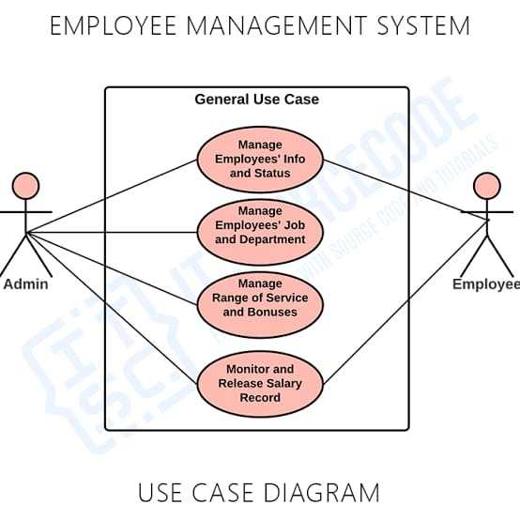

**Explanation**

* The above Diagram show the permission of accessing data to Employee & admin, By using Get access button.
* It means that, application provided Accessing functionality to user for secure data & and only valid person can access data and make changes.s

**Use Flowchart**

* Used flow chart for describe the flow of data of Employee step by step fill information .
* It also describe the high-level functionality using for secure salary record. & flow chart helps to identify the interaction between one page to another page(jframe)
* **flowchart System Architecture**

Start

Enter to Login Page

Fill Out all the Information

Registration

NO

Have User ID & Password

Login

Submit

Employee Salary Record

**Save**

Display Salary Record

Project Head

Manager

Add Record

Registration

Stop

**Code**

**Login.java**

package employeproject1;

import java.sql.*;

import javax.swing.JOptionPane;

public class Login extends javax.swing.JFrame {

public Login() {

initComponents();

}

@SuppressWarnings("unchecked")

// <editor-fold defaultstate="collapsed" desc="Generated Code">

private void initComponents() {

jPanel1 = new javax.swing.JPanel();

jPanel2 = new javax.swing.JPanel();

jLabel2 = new javax.swing.JLabel();

jLabel3 = new javax.swing.JLabel();

jLabel4 = new javax.swing.JLabel();

jLabel5 = new javax.swing.JLabel();

userid = new javax.swing.JLabel();

jLabel7 = new javax.swing.JLabel();

jLabel8 = new javax.swing.JLabel();

SignIn = new javax.swing.JButton();

EmployeeName = new javax.swing.JTextField();

E_userName = new javax.swing.JTextField();

close = new javax.swing.JButton();

E_password = new javax.swing.JPasswordField();

Register = new javax.swing.JButton();

setDefaultCloseOperation(javax.swing.WindowConstants.EXIT_ON_CLOSE);

setTitle("Sign Up");

setUndecorated(true);

setResizable(false);

jPanel1.setBackground(new java.awt.Color(255, 255, 255));

jPanel1.setFont(new java.awt.Font("Calibri", 0, 18)); // NOI18N

jPanel2.setBackground(new java.awt.Color(0, 0, 0));

jLabel2.setIcon(new javax.swing.ImageIcon("C:\\Users\\kaiva\\Desktop\\Employee project\\Login\\pro.jpeg")); // NOI18N

jLabel2.setText("jLabel2");

jLabel3.setIcon(new javax.swing.ImageIcon("C:\\Users\\kaiva\\Desktop\\Employee project\\Login\\Employe.jpeg")); // NOI18N

jLabel4.setIcon(new javax.swing.ImageIcon("C:\\Users\\kaiva\\Desktop\\Employee project\\Login\\Employe login.jpeg")); // NOI18N

javax.swing.GroupLayout jPanel2Layout = new javax.swing.GroupLayout(jPanel2);

jPanel2.setLayout(jPanel2Layout);

jPanel2Layout.setHorizontalGroup(

jPanel2Layout.createParallelGroup(javax.swing.GroupLayout.Alignment.LEADING)

.addGroup(jPanel2Layout.createSequentialGroup()

.addGap(30, 30, 30)

.addComponent(jLabel3, javax.swing.GroupLayout.PREFERRED_SIZE, 64, javax.swing.GroupLayout.PREFERRED_SIZE)

.addPreferredGap(javax.swing.LayoutStyle.ComponentPlacement.RELATED)

.addComponent(jLabel4, javax.swing.GroupLayout.PREFERRED_SIZE, 169, javax.swing.GroupLayout.PREFERRED_SIZE)

.addContainerGap(javax.swing.GroupLayout.DEFAULT_SIZE, Short.MAX_VALUE))

.addComponent(jLabel2, javax.swing.GroupLayout.Alignment.TRAILING, javax.swing.GroupLayout.PREFERRED_SIZE, 283, Short.MAX_VALUE)

);

jPanel2Layout.setVerticalGroup(

jPanel2Layout.createParallelGroup(javax.swing.GroupLayout.Alignment.LEADING)

.addGroup(jPanel2Layout.createSequentialGroup()

.addContainerGap()

.addComponent(jLabel2, javax.swing.GroupLayout.PREFERRED_SIZE, 216, javax.swing.GroupLayout.PREFERRED_SIZE)

.addGap(55, 55, 55)

.addGroup(jPanel2Layout.createParallelGroup(javax.swing.GroupLayout.Alignment.TRAILING)

.addComponent(jLabel4, javax.swing.GroupLayout.PREFERRED_SIZE, 36, javax.swing.GroupLayout.PREFERRED_SIZE)

.addComponent(jLabel3, javax.swing.GroupLayout.PREFERRED_SIZE, 50, javax.swing.GroupLayout.PREFERRED_SIZE))

.addContainerGap(javax.swing.GroupLayout.DEFAULT_SIZE, Short.MAX_VALUE))

);

jLabel5.setBackground(new java.awt.Color(0, 0, 0));

jLabel5.setFont(new java.awt.Font("Cambria", 0, 36)); // NOI18N

jLabel5.setHorizontalAlignment(javax.swing.SwingConstants.CENTER);

jLabel5.setText("Sign Up");

userid.setFont(new java.awt.Font("Calibri", 0, 12)); // NOI18N

userid.setForeground(new java.awt.Color(51, 51, 51));

userid.setText("Login ID");

jLabel7.setFont(new java.awt.Font("Calibri", 0, 12)); // NOI18N

jLabel7.setForeground(new java.awt.Color(51, 51, 51));

jLabel7.setText("User Name");

jLabel8.setFont(new java.awt.Font("Calibri", 0, 12)); // NOI18N

jLabel8.setForeground(new java.awt.Color(51, 51, 51));

jLabel8.setText("Password");

SignIn.setBackground(new java.awt.Color(255, 255, 255));

SignIn.setFont(new java.awt.Font("Calibri", 0, 18)); // NOI18N

SignIn.setForeground(new java.awt.Color(255, 255, 255));

SignIn.setIcon(new javax.swing.ImageIcon("C:\\Users\\kaiva\\Desktop\\Employee project\\signkk.png")); // NOI18N

SignIn.setBorder(new javax.swing.border.LineBorder(new java.awt.Color(255, 255, 255), 10, true));

SignIn.setBorderPainted(false);

SignIn.setContentAreaFilled(false);

SignIn.setCursor(new java.awt.Cursor(java.awt.Cursor.HAND_CURSOR));

SignIn.addActionListener(new java.awt.event.ActionListener() {

public void actionPerformed(java.awt.event.ActionEvent evt) {

SignInActionPerformed(evt);

}

});

EmployeeName.setFont(new java.awt.Font("Cambria Math", 0, 18)); // NOI18N

EmployeeName.setForeground(new java.awt.Color(51, 51, 51));

EmployeeName.setBorder(javax.swing.BorderFactory.createLineBorder(new java.awt.Color(51, 51, 51)));

EmployeeName.addActionListener(new java.awt.event.ActionListener() {

public void actionPerformed(java.awt.event.ActionEvent evt) {

EmployeeNameActionPerformed(evt);

}

});

E_userName.setFont(new java.awt.Font("Cambria Math", 0, 18)); // NOI18N

E_userName.setForeground(new java.awt.Color(51, 51, 51));

E_userName.setBorder(javax.swing.BorderFactory.createLineBorder(new java.awt.Color(51, 51, 51)));

E_userName.addActionListener(new java.awt.event.ActionListener() {

public void actionPerformed(java.awt.event.ActionEvent evt) {

E_userNameActionPerformed(evt);

}

});

close.setBackground(new java.awt.Color(255, 255, 255));

close.setFont(new java.awt.Font("Tahoma", 0, 18)); // NOI18N

close.setText("X");

close.setBorder(javax.swing.BorderFactory.createLineBorder(new java.awt.Color(0, 0, 0), 2));

close.addActionListener(new java.awt.event.ActionListener() {

public void actionPerformed(java.awt.event.ActionEvent evt) {

closeActionPerformed(evt);

}

});

E_password.setFont(new java.awt.Font("Cambria Math", 0, 18)); // NOI18N

E_password.setForeground(new java.awt.Color(52, 52, 52));

E_password.setBorder(new javax.swing.border.LineBorder(new java.awt.Color(51, 51, 51), 1, true));

E_password.addActionListener(new java.awt.event.ActionListener() {

public void actionPerformed(java.awt.event.ActionEvent evt) {

E_passwordActionPerformed(evt);

}

});

Register.setBackground(new java.awt.Color(0, 153, 255));

Register.setFont(new java.awt.Font("Calibri", 0, 18)); // NOI18N

Register.setForeground(new java.awt.Color(0, 0, 102));

Register.setIcon(new javax.swing.ImageIcon("C:\\Users\\kaiva\\Desktop\\Employee project\\registerkk.png")); // NOI18N

Register.setBorder(null);

Register.setContentAreaFilled(false);

Register.setCursor(new java.awt.Cursor(java.awt.Cursor.HAND_CURSOR));

Register.addActionListener(new java.awt.event.ActionListener() {

public void actionPerformed(java.awt.event.ActionEvent evt) {

RegisterActionPerformed(evt);

}

});

javax.swing.GroupLayout jPanel1Layout = new javax.swing.GroupLayout(jPanel1);

jPanel1.setLayout(jPanel1Layout);

jPanel1Layout.setHorizontalGroup(

jPanel1Layout.createParallelGroup(javax.swing.GroupLayout.Alignment.LEADING)

.addGroup(jPanel1Layout.createSequentialGroup()

.addComponent(jPanel2, javax.swing.GroupLayout.PREFERRED_SIZE, javax.swing.GroupLayout.DEFAULT_SIZE, javax.swing.GroupLayout.PREFERRED_SIZE)

.addGroup(jPanel1Layout.createParallelGroup(javax.swing.GroupLayout.Alignment.LEADING)

.addGroup(jPanel1Layout.createSequentialGroup()

.addGroup(jPanel1Layout.createParallelGroup(javax.swing.GroupLayout.Alignment.LEADING)

.addGroup(jPanel1Layout.createSequentialGroup()

.addGap(50, 50, 50)

.addGroup(jPanel1Layout.createParallelGroup(javax.swing.GroupLayout.Alignment.LEADING)

.addComponent(jLabel7, javax.swing.GroupLayout.PREFERRED_SIZE, 78, javax.swing.GroupLayout.PREFERRED_SIZE)

.addComponent(EmployeeName, javax.swing.GroupLayout.PREFERRED_SIZE, 263, javax.swing.GroupLayout.PREFERRED_SIZE)

.addComponent(userid, javax.swing.GroupLayout.PREFERRED_SIZE, 78, javax.swing.GroupLayout.PREFERRED_SIZE)

.addComponent(E_userName, javax.swing.GroupLayout.PREFERRED_SIZE, 263, javax.swing.GroupLayout.PREFERRED_SIZE)

.addComponent(jLabel8, javax.swing.GroupLayout.PREFERRED_SIZE, 78, javax.swing.GroupLayout.PREFERRED_SIZE)

.addComponent(E_password, javax.swing.GroupLayout.PREFERRED_SIZE, 263, javax.swing.GroupLayout.PREFERRED_SIZE)))

.addGroup(jPanel1Layout.createSequentialGroup()

.addGap(80, 80, 80)

.addComponent(jLabel5, javax.swing.GroupLayout.PREFERRED_SIZE, 168, javax.swing.GroupLayout.PREFERRED_SIZE))

.addGroup(jPanel1Layout.createSequentialGroup()

.addGap(27, 27, 27)

.addComponent(SignIn, javax.swing.GroupLayout.PREFERRED_SIZE, 138, javax.swing.GroupLayout.PREFERRED_SIZE)

.addGap(35, 35, 35)

.addComponent(Register)))

.addGap(0, 22, Short.MAX_VALUE))

.addGroup(javax.swing.GroupLayout.Alignment.TRAILING, jPanel1Layout.createSequentialGroup()

.addPreferredGap(javax.swing.LayoutStyle.ComponentPlacement.RELATED, javax.swing.GroupLayout.DEFAULT_SIZE, Short.MAX_VALUE)

.addComponent(close, javax.swing.GroupLayout.PREFERRED_SIZE, 31, javax.swing.GroupLayout.PREFERRED_SIZE)))

.addContainerGap())

);

jPanel1Layout.setVerticalGroup(

jPanel1Layout.createParallelGroup(javax.swing.GroupLayout.Alignment.LEADING)

.addGroup(jPanel1Layout.createSequentialGroup()

.addComponent(close)

.addGap(47, 47, 47)

.addComponent(jLabel5)

.addGap(18, 18, 18)

.addComponent(jLabel7)

.addGap(11, 11, 11)

.addComponent(EmployeeName, javax.swing.GroupLayout.PREFERRED_SIZE, 40, javax.swing.GroupLayout.PREFERRED_SIZE)

.addGap(16, 16, 16)

.addComponent(userid)

.addPreferredGap(javax.swing.LayoutStyle.ComponentPlacement.RELATED)

.addComponent(E_userName, javax.swing.GroupLayout.PREFERRED_SIZE, 40, javax.swing.GroupLayout.PREFERRED_SIZE)

.addGap(18, 18, 18)

.addComponent(jLabel8)

.addPreferredGap(javax.swing.LayoutStyle.ComponentPlacement.RELATED)

.addComponent(E_password, javax.swing.GroupLayout.PREFERRED_SIZE, 39, javax.swing.GroupLayout.PREFERRED_SIZE)

.addGap(33, 33, 33)

.addGroup(jPanel1Layout.createParallelGroup(javax.swing.GroupLayout.Alignment.LEADING)

.addComponent(SignIn, javax.swing.GroupLayout.PREFERRED_SIZE, 51, javax.swing.GroupLayout.PREFERRED_SIZE)

.addComponent(Register, javax.swing.GroupLayout.PREFERRED_SIZE, 51, javax.swing.GroupLayout.PREFERRED_SIZE))

.addContainerGap(45, Short.MAX_VALUE))

.addComponent(jPanel2, javax.swing.GroupLayout.DEFAULT_SIZE, javax.swing.GroupLayout.DEFAULT_SIZE, Short.MAX_VALUE)

);

javax.swing.GroupLayout layout = new javax.swing.GroupLayout(getContentPane());

getContentPane().setLayout(layout);

layout.setHorizontalGroup(

layout.createParallelGroup(javax.swing.GroupLayout.Alignment.LEADING)

.addGroup(layout.createSequentialGroup()

.addComponent(jPanel1, javax.swing.GroupLayout.PREFERRED_SIZE, javax.swing.GroupLayout.DEFAULT_SIZE, javax.swing.GroupLayout.PREFERRED_SIZE)

.addGap(0, 0, Short.MAX_VALUE))

);

layout.setVerticalGroup(

layout.createParallelGroup(javax.swing.GroupLayout.Alignment.LEADING)

.addComponent(jPanel1, javax.swing.GroupLayout.PREFERRED_SIZE, javax.swing.GroupLayout.DEFAULT_SIZE, javax.swing.GroupLayout.PREFERRED_SIZE)

);

setSize(new java.awt.Dimension(636, 472));

setLocationRelativeTo(null);

}// </editor-fold>

private void E_userNameActionPerformed(java.awt.event.ActionEvent evt) {

// TODO add your handling code here:

}

private void EmployeeNameActionPerformed(java.awt.event.ActionEvent evt) {

// TODO add your handling code here:

}

private void SignInActionPerformed(java.awt.event.ActionEvent evt) {

String name = EmployeeName.getText();

String user = E_userName.getText();

String pa = E_password.getText();

try{

Class.forName("com.mysql.cj.jdbc.Driver");

Connection con = DriverManager.getConnection("jdbc:mysql://localhost/employeelogin1","root","");

Statement stmt = con.createStatement();

ResultSet rs = stmt.executeQuery("select User_Name,password from Employee_Registration1 where User_Name='"+user+"' and password='"+pa+"'");

if(rs.next()){

KalvenID obj= new KalvenID();

obj.setVisible(true);

}

else{

JOptionPane.showMessageDialog(null,"Username And Password is incorrect");

}

con.close();

}

catch(Exception e){

System.out.println(e);

}

try {

Class.forName("com.mysql.cj.jdbc.Driver");

Connection con = DriverManager.getConnection("jdbc:mysql://localhost/employeelogin1","root","");

String query = "insert into Login_Info(User_Name,Login_Id,Password,Date)values(?,?,?,?);";

PreparedStatement pst = con.prepareStatement(query);

pst.setString(1, EmployeeName.getText());

pst.setString(2, E_userName.getText());

pst.setString(3, E_password.getText());

pst.setDate(4, new java.sql.Date(System.currentTimeMillis()));

pst.executeUpdate();

}

catch(Exception e){

System.out.println(e);

} }

private void closeActionPerformed(java.awt.event.ActionEvent evt) {

dispose();

}

private void E_passwordActionPerformed(java.awt.event.ActionEvent evt) {

// TODO add your handling code here:

}

private void RegisterActionPerformed(java.awt.event.ActionEvent evt) {

// TODO add your handling code here:

NewEmployee lh = new NewEmployee();

lh.setVisible(true);

}

private void EmployeeNameKeyReleased(java.awt.event.KeyEvent evt) {

// TODO add your handling code here:

String PATTERN ="[0-9]{1,30}";

Pattern patt=Pattern.compile(PATTERN);

Matcher match=patt.matcher(EmployeeName.getText());

if(match.matches()){

JOptionPane.showMessageDialog(null,"please enter valid Name!");

}

else{}

}

public static void main(String args[]) {

/* Set the Nimbus look and feel */

//<editor-fold defaultstate="collapsed" desc=" Look and feel setting code (optional) ">

/* If Nimbus (introduced in Java SE 6) is not available, stay with the default look and feel.

* For details see http://download.oracle.com/javase/tutorial/uiswing/lookandfeel/plaf.html

*/

try {

for (javax.swing.UIManager.LookAndFeelInfo info : javax.swing.UIManager.getInstalledLookAndFeels()) {

if ("Nimbus".equals(info.getName())) {

javax.swing.UIManager.setLookAndFeel(info.getClassName());

break;

}

}

} catch (ClassNotFoundException ex) {

java.util.logging.Logger.getLogger(Login.class.getName()).log(java.util.logging.Level.SEVERE, null, ex);

} catch (InstantiationException ex) {

java.util.logging.Logger.getLogger(Login.class.getName()).log(java.util.logging.Level.SEVERE, null, ex);

} catch (IllegalAccessException ex) {

java.util.logging.Logger.getLogger(Login.class.getName()).log(java.util.logging.Level.SEVERE, null, ex);

} catch (javax.swing.UnsupportedLookAndFeelException ex) {

java.util.logging.Logger.getLogger(Login.class.getName()).log(java.util.logging.Level.SEVERE, null, ex);

}

//</editor-fold>

/* Create and display the form */

java.awt.EventQueue.invokeLater(new Runnable() {

public void run() {

new Login().setVisible(true);

}

});

}

// Variables declaration - do not modify

private javax.swing.JPasswordField E_password;

private javax.swing.JTextField E_userName;

private javax.swing.JTextField EmployeeName;

private javax.swing.JButton Register;

private javax.swing.JButton SignIn;

private javax.swing.JButton close;

private javax.swing.JLabel jLabel2;

private javax.swing.JLabel jLabel3;

private javax.swing.JLabel jLabel4;

private javax.swing.JLabel jLabel5;

private javax.swing.JLabel jLabel7;

private javax.swing.JLabel jLabel8;

private javax.swing.JPanel jPanel1;

private javax.swing.JPanel jPanel2;

private javax.swing.JLabel userid;

// End of variables declaration

}

**Output :**

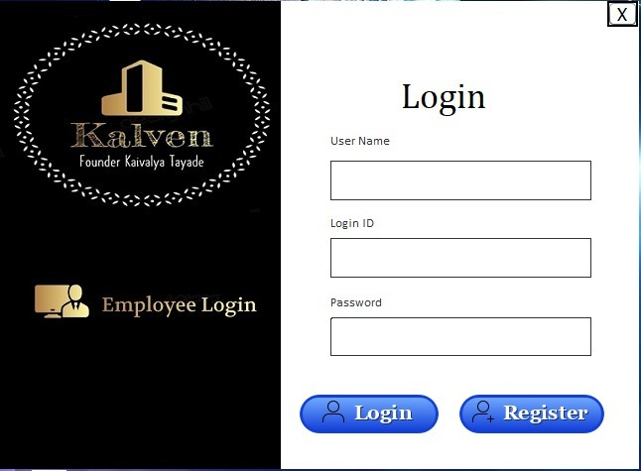

**After Click on Register button**

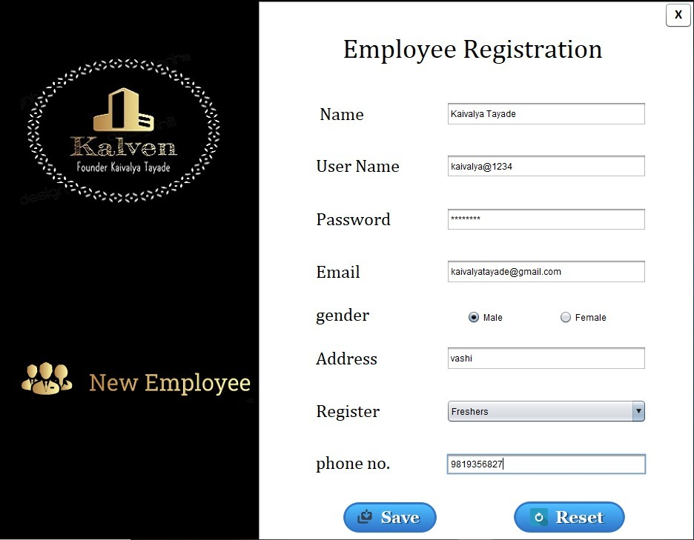

**Enter Login ID and Password**

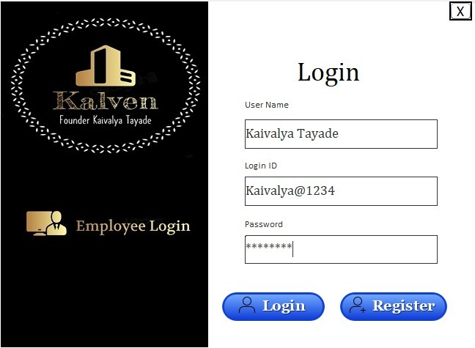

**Login information(log_info table)**

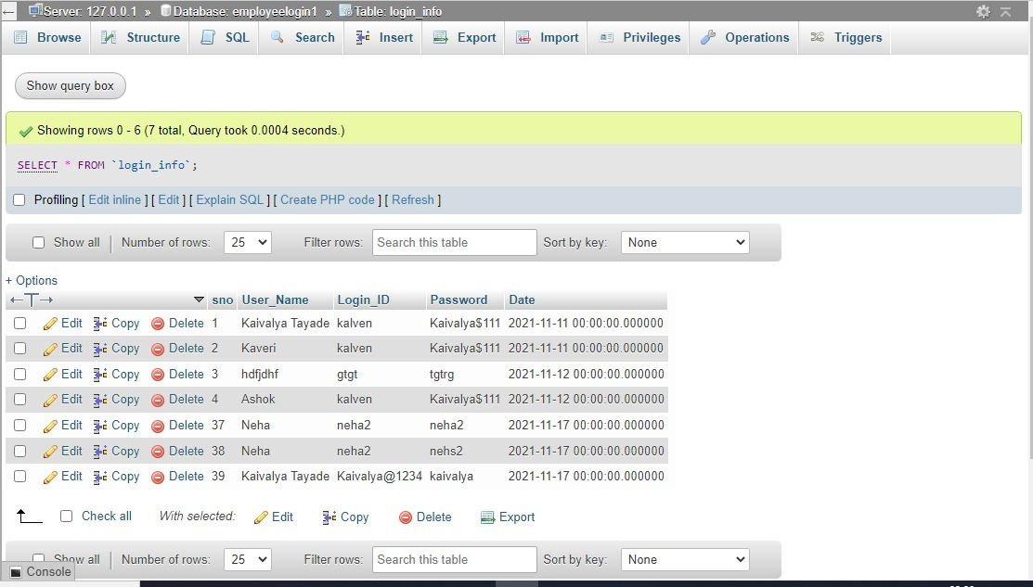

**After Click on Login button**

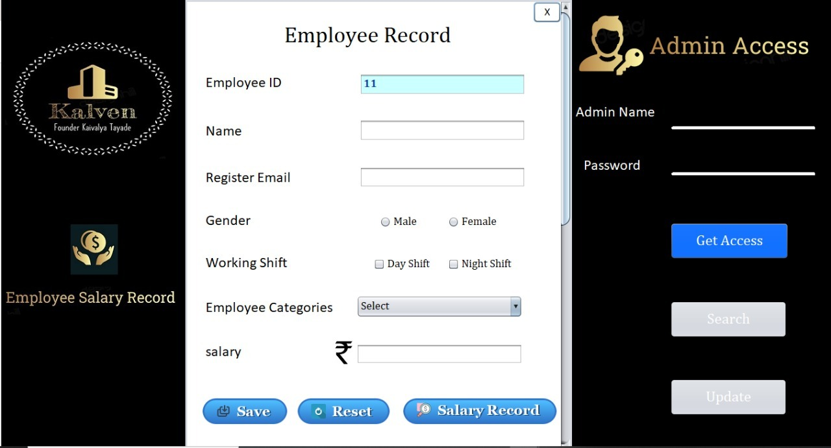

**Validation**

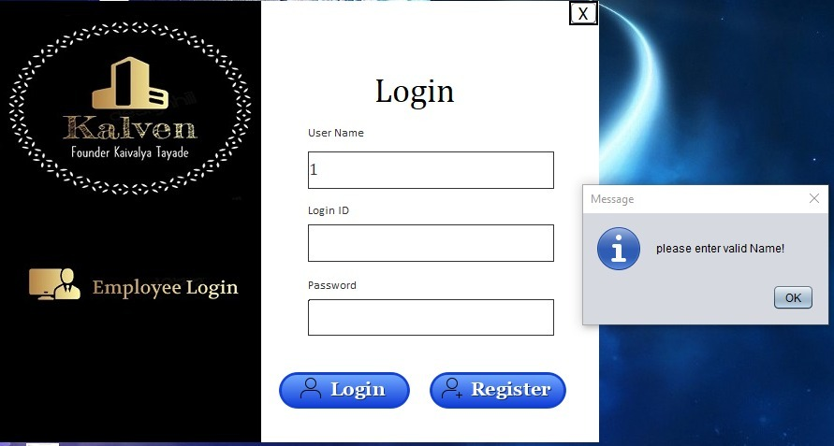

**New Employee.java**

package employeproject1;

import java.util.regex.*;

//java Regex or Regular Expression is an API to define a pattern for searching or manipulating strings.

//It is widely used to define the constraint on strings such as password and email validation

import java.sql.Connection;

import java.sql.DriverManager;

import java.sql.PreparedStatement;

import java.text.SimpleDateFormat;

import java.util.Date;

import javax.swing.JOptionPane;

public class NewEmployee extends javax.swing.JFrame {

String gender;

public NewEmployee() {

initComponents();

}

@SuppressWarnings("unchecked")

// <editor-fold defaultstate="collapsed" desc="Generated Code">

private void initComponents() {

buttonGroup1 = new javax.swing.ButtonGroup();

buttonGroup2 = new javax.swing.ButtonGroup();

buttonGroup3 = new javax.swing.ButtonGroup();

buttonGroup4 = new javax.swing.ButtonGroup();

jPanel2 = new javax.swing.JPanel();

jLabel8 = new javax.swing.JLabel();

jLabel9 = new javax.swing.JLabel();

jLabel10 = new javax.swing.JLabel();

jScrollPane1 = new javax.swing.JScrollPane();

jPanel1 = new javax.swing.JPanel();

close = new javax.swing.JButton();

jLabel1 = new javax.swing.JLabel();

jLabel2 = new javax.swing.JLabel();

Name = new javax.swing.JTextField();

jLabel3 = new javax.swing.JLabel();

Email = new javax.swing.JTextField();

jLabel4 = new javax.swing.JLabel();

Male = new javax.swing.JRadioButton();

Female = new javax.swing.JRadioButton();

jLabel5 = new javax.swing.JLabel();

Address = new javax.swing.JTextField();

Register = new javax.swing.JComboBox();

jLabel6 = new javax.swing.JLabel();

jLabel7 = new javax.swing.JLabel();

phone_No = new javax.swing.JTextField();

Rsave = new javax.swing.JButton();

Rreset = new javax.swing.JButton();

jLabel11 = new javax.swing.JLabel();

jLabel12 = new javax.swing.JLabel();

User_Name = new javax.swing.JTextField();

password = new javax.swing.JPasswordField();

NAME = new javax.swing.JLabel();

USERNAME = new javax.swing.JLabel();

PHONE = new javax.swing.JLabel();

GENDER = new javax.swing.JLabel();

ADDRESS = new javax.swing.JLabel();

REGISTER = new javax.swing.JLabel();

PASSWORD = new javax.swing.JLabel();

EMAIL = new javax.swing.JLabel();

setDefaultCloseOperation(javax.swing.WindowConstants.EXIT_ON_CLOSE);

setUndecorated(true);

jPanel2.setBackground(new java.awt.Color(0, 0, 0));

jLabel8.setIcon(new javax.swing.ImageIcon("C:\\Users\\kaiva\\Desktop\\Employee project\\New_Employee\\kaivalya.jpg")); // NOI18N

jLabel9.setIcon(new javax.swing.ImageIcon(getClass().getResource("/employeproject1/New Employee.PNG"))); // NOI18N

jLabel10.setIcon(new javax.swing.ImageIcon("C:\\Users\\kaiva\\Desktop\\project files\\Registration final1.png")); // NOI18N

jPanel1.setBackground(new java.awt.Color(255, 255, 255));

close.setBackground(new java.awt.Color(255, 255, 255));

close.setFont(new java.awt.Font("Calibri", 1, 18)); // NOI18N

close.setText("X");

close.addActionListener(new java.awt.event.ActionListener() {

public void actionPerformed(java.awt.event.ActionEvent evt) {

closeActionPerformed(evt);

}

});

jLabel1.setFont(new java.awt.Font("Cambria Math", 0, 36)); // NOI18N

jLabel1.setText("Employee Registration");

jLabel2.setFont(new java.awt.Font("Cambria Math", 0, 24)); // NOI18N

jLabel2.setText(" Name");

Name.setFont(new java.awt.Font("Cambria Math", 0, 14)); // NOI18N

Name.addActionListener(new java.awt.event.ActionListener() {

public void actionPerformed(java.awt.event.ActionEvent evt) {

NameActionPerformed(evt);

}

});

Name.addKeyListener(new java.awt.event.KeyAdapter() {

public void keyReleased(java.awt.event.KeyEvent evt) {

NameKeyReleased(evt);

}

});

jLabel3.setFont(new java.awt.Font("Cambria Math", 0, 24)); // NOI18N

jLabel3.setText("gender");

Email.addActionListener(new java.awt.event.ActionListener() {

public void actionPerformed(java.awt.event.ActionEvent evt) {

EmailActionPerformed(evt);

}

});

Email.addKeyListener(new java.awt.event.KeyAdapter() {

public void keyReleased(java.awt.event.KeyEvent evt) {

EmailKeyReleased(evt);

}

});

jLabel4.setFont(new java.awt.Font("Cambria Math", 0, 24)); // NOI18N

jLabel4.setText("Email");

buttonGroup3.add(Male);

Male.setFont(new java.awt.Font("Cambria Math", 0, 14)); // NOI18N

Male.setText("Male");

Male.addActionListener(new java.awt.event.ActionListener() {

public void actionPerformed(java.awt.event.ActionEvent evt) {

MaleActionPerformed(evt);

}

});

buttonGroup3.add(Female);

Female.setFont(new java.awt.Font("Cambria Math", 0, 14)); // NOI18N

Female.setText("Female");

Female.addActionListener(new java.awt.event.ActionListener() {

public void actionPerformed(java.awt.event.ActionEvent evt) {

FemaleActionPerformed(evt);

}

});

jLabel5.setFont(new java.awt.Font("Cambria Math", 0, 24)); // NOI18N

jLabel5.setText("phone no.");

Address.setFont(new java.awt.Font("Cambria Math", 0, 14)); // NOI18N

Address.addKeyListener(new java.awt.event.KeyAdapter() {

public void keyReleased(java.awt.event.KeyEvent evt) {

AddressKeyReleased(evt);

}

});

Register.setFont(new java.awt.Font("Cambria Math", 0, 14)); // NOI18N

Register.setModel(new javax.swing.DefaultComboBoxModel(new String[] { "Freshers", "Old Employee", " " }));

Register.addMouseListener(new java.awt.event.MouseAdapter() {

public void mouseClicked(java.awt.event.MouseEvent evt) {

RegisterMouseClicked(evt);

}

});

Register.addActionListener(new java.awt.event.ActionListener() {

public void actionPerformed(java.awt.event.ActionEvent evt) {

RegisterActionPerformed(evt);

}

});

Register.addKeyListener(new java.awt.event.KeyAdapter() {

public void keyPressed(java.awt.event.KeyEvent evt) {

RegisterKeyPressed(evt);

}

public void keyReleased(java.awt.event.KeyEvent evt) {

RegisterKeyReleased(evt);

}

public void keyTyped(java.awt.event.KeyEvent evt) {

RegisterKeyTyped(evt);

}

});

jLabel6.setFont(new java.awt.Font("Cambria Math", 0, 24)); // NOI18N

jLabel6.setText("Address");

jLabel7.setFont(new java.awt.Font("Cambria Math", 0, 24)); // NOI18N

jLabel7.setText("Register");

phone_No.setFont(new java.awt.Font("Cambria Math", 0, 14)); // NOI18N

phone_No.addActionListener(new java.awt.event.ActionListener() {

public void actionPerformed(java.awt.event.ActionEvent evt) {

phone_NoActionPerformed(evt);

}

});

phone_No.addKeyListener(new java.awt.event.KeyAdapter() {

public void keyReleased(java.awt.event.KeyEvent evt) {

phone_NoKeyReleased(evt);

}

});

Rsave.setBackground(new java.awt.Color(0, 204, 255));

Rsave.setFont(new java.awt.Font("Cambria Math", 0, 24)); // NOI18N

Rsave.setForeground(new java.awt.Color(0, 0, 102));

Rsave.setIcon(new javax.swing.ImageIcon("C:\\Users\\kaiva\\Desktop\\Employee project\\save.png")); // NOI18N

Rsave.setBorder(null);

Rsave.setContentAreaFilled(false);

Rsave.addActionListener(new java.awt.event.ActionListener() {

public void actionPerformed(java.awt.event.ActionEvent evt) {

RsaveActionPerformed(evt);

}

});

Rreset.setBackground(new java.awt.Color(0, 204, 255));

Rreset.setFont(new java.awt.Font("Cambria Math", 0, 24)); // NOI18N

Rreset.setForeground(new java.awt.Color(0, 0, 102));

Rreset.setIcon(new javax.swing.ImageIcon("C:\\Users\\kaiva\\Desktop\\Employee project\\Reset1.png")); // NOI18N

Rreset.setBorder(null);

Rreset.setContentAreaFilled(false);

Rreset.addActionListener(new java.awt.event.ActionListener() {

public void actionPerformed(java.awt.event.ActionEvent evt) {

RresetActionPerformed(evt);

}

});

jLabel11.setFont(new java.awt.Font("Cambria Math", 0, 24)); // NOI18N

jLabel11.setText("Password");

jLabel12.setFont(new java.awt.Font("Cambria Math", 0, 24)); // NOI18N

jLabel12.setText("User Name");

User_Name.setFont(new java.awt.Font("Cambria Math", 0, 14)); // NOI18N

User_Name.addKeyListener(new java.awt.event.KeyAdapter() {

public void keyReleased(java.awt.event.KeyEvent evt) {

User_NameKeyReleased(evt);

}

});

password.setFont(new java.awt.Font("Cambria Math", 0, 14)); // NOI18N

password.addKeyListener(new java.awt.event.KeyAdapter() {

public void keyReleased(java.awt.event.KeyEvent evt) {

passwordKeyReleased(evt);

}

});

NAME.setForeground(new java.awt.Color(255, 0, 0));

USERNAME.setForeground(new java.awt.Color(255, 0, 0));

PHONE.setForeground(new java.awt.Color(255, 0, 0));

PHONE.addKeyListener(new java.awt.event.KeyAdapter() {

public void keyReleased(java.awt.event.KeyEvent evt) {

PHONEKeyReleased(evt);

}

});

GENDER.setForeground(new java.awt.Color(255, 0, 0));

ADDRESS.setForeground(new java.awt.Color(255, 0, 0));

REGISTER.setForeground(new java.awt.Color(255, 0, 0));

PASSWORD.setForeground(new java.awt.Color(255, 0, 0));

EMAIL.setForeground(new java.awt.Color(255, 0, 0));

javax.swing.GroupLayout jPanel1Layout = new javax.swing.GroupLayout(jPanel1);

jPanel1.setLayout(jPanel1Layout);

jPanel1Layout.setHorizontalGroup(

jPanel1Layout.createParallelGroup(javax.swing.GroupLayout.Alignment.LEADING)

.addGroup(jPanel1Layout.createSequentialGroup()

.addGap(112, 112, 112)

.addComponent(jLabel1, javax.swing.GroupLayout.PREFERRED_SIZE, 364, javax.swing.GroupLayout.PREFERRED_SIZE)

.addContainerGap(javax.swing.GroupLayout.DEFAULT_SIZE, Short.MAX_VALUE))

.addGroup(jPanel1Layout.createSequentialGroup()

.addGap(76, 76, 76)

.addGroup(jPanel1Layout.createParallelGroup(javax.swing.GroupLayout.Alignment.LEADING)

.addGroup(jPanel1Layout.createSequentialGroup()

.addGap(22, 22, 22)

.addComponent(Rsave, javax.swing.GroupLayout.PREFERRED_SIZE, 156, javax.swing.GroupLayout.PREFERRED_SIZE)

.addGap(86, 86, 86)

.addComponent(Rreset, javax.swing.GroupLayout.PREFERRED_SIZE, 156, javax.swing.GroupLayout.PREFERRED_SIZE))

.addGroup(jPanel1Layout.createParallelGroup(javax.swing.GroupLayout.Alignment.TRAILING)

.addComponent(close)

.addGroup(jPanel1Layout.createSequentialGroup()

.addGroup(jPanel1Layout.createParallelGroup(javax.swing.GroupLayout.Alignment.LEADING, false)

.addGroup(jPanel1Layout.createSequentialGroup()

.addGroup(jPanel1Layout.createParallelGroup(javax.swing.GroupLayout.Alignment.LEADING)

.addComponent(jLabel2)

.addComponent(jLabel7)

.addComponent(jLabel12)

.addComponent(jLabel4)

.addComponent(jLabel11)

.addComponent(jLabel6)

.addComponent(jLabel5))

.addGap(63, 63, 63)

.addGroup(jPanel1Layout.createParallelGroup(javax.swing.GroupLayout.Alignment.TRAILING)

.addGroup(jPanel1Layout.createParallelGroup(javax.swing.GroupLayout.Alignment.LEADING, false)

.addComponent(Email, javax.swing.GroupLayout.DEFAULT_SIZE, 270, Short.MAX_VALUE)

.addComponent(Name, javax.swing.GroupLayout.DEFAULT_SIZE, 270, Short.MAX_VALUE)

.addComponent(User_Name)

.addComponent(password))

.addComponent(Register, javax.swing.GroupLayout.Alignment.LEADING, javax.swing.GroupLayout.PREFERRED_SIZE, 270, javax.swing.GroupLayout.PREFERRED_SIZE)

.addComponent(Address, javax.swing.GroupLayout.Alignment.LEADING, javax.swing.GroupLayout.PREFERRED_SIZE, 270, javax.swing.GroupLayout.PREFERRED_SIZE)

.addComponent(phone_No, javax.swing.GroupLayout.Alignment.LEADING, javax.swing.GroupLayout.PREFERRED_SIZE, 270, javax.swing.GroupLayout.PREFERRED_SIZE))

.addPreferredGap(javax.swing.LayoutStyle.ComponentPlacement.RELATED))

.addGroup(jPanel1Layout.createSequentialGroup()

.addComponent(jLabel3)

.addGap(132, 132, 132)

.addComponent(Male)

.addPreferredGap(javax.swing.LayoutStyle.ComponentPlacement.RELATED, javax.swing.GroupLayout.DEFAULT_SIZE, Short.MAX_VALUE)

.addComponent(Female)

.addGap(45, 45, 45)))

.addGroup(jPanel1Layout.createParallelGroup(javax.swing.GroupLayout.Alignment.LEADING)

.addComponent(GENDER, javax.swing.GroupLayout.PREFERRED_SIZE, 207, javax.swing.GroupLayout.PREFERRED_SIZE)

.addComponent(NAME, javax.swing.GroupLayout.PREFERRED_SIZE, 207, javax.swing.GroupLayout.PREFERRED_SIZE)

.addComponent(USERNAME, javax.swing.GroupLayout.PREFERRED_SIZE, 207, javax.swing.GroupLayout.PREFERRED_SIZE)

.addComponent(PHONE, javax.swing.GroupLayout.PREFERRED_SIZE, 207, javax.swing.GroupLayout.PREFERRED_SIZE)

.addComponent(ADDRESS, javax.swing.GroupLayout.PREFERRED_SIZE, 207, javax.swing.GroupLayout.PREFERRED_SIZE)

.addComponent(REGISTER, javax.swing.GroupLayout.PREFERRED_SIZE, 207, javax.swing.GroupLayout.PREFERRED_SIZE)

.addComponent(PASSWORD, javax.swing.GroupLayout.PREFERRED_SIZE, 207, javax.swing.GroupLayout.PREFERRED_SIZE)

.addComponent(EMAIL, javax.swing.GroupLayout.PREFERRED_SIZE, 207, javax.swing.GroupLayout.PREFERRED_SIZE)))))

.addGap(0, 244, Short.MAX_VALUE))

);

jPanel1Layout.setVerticalGroup(

jPanel1Layout.createParallelGroup(javax.swing.GroupLayout.Alignment.LEADING)

.addGroup(jPanel1Layout.createSequentialGroup()

.addComponent(close, javax.swing.GroupLayout.PREFERRED_SIZE, 35, javax.swing.GroupLayout.PREFERRED_SIZE)

.addGap(9, 9, 9)

.addGroup(jPanel1Layout.createParallelGroup(javax.swing.GroupLayout.Alignment.TRAILING)

.addGroup(jPanel1Layout.createSequentialGroup()

.addGroup(jPanel1Layout.createParallelGroup(javax.swing.GroupLayout.Alignment.TRAILING)

.addGroup(jPanel1Layout.createSequentialGroup()

.addComponent(jLabel1, javax.swing.GroupLayout.PREFERRED_SIZE, 42, javax.swing.GroupLayout.PREFERRED_SIZE)

.addGap(48, 48, 48)

.addGroup(jPanel1Layout.createParallelGroup(javax.swing.GroupLayout.Alignment.LEADING)

.addGroup(jPanel1Layout.createParallelGroup(javax.swing.GroupLayout.Alignment.TRAILING)

.addComponent(jLabel2)

.addComponent(Name, javax.swing.GroupLayout.PREFERRED_SIZE, 33, javax.swing.GroupLayout.PREFERRED_SIZE))

.addComponent(NAME, javax.swing.GroupLayout.Alignment.TRAILING, javax.swing.GroupLayout.PREFERRED_SIZE, 33, javax.swing.GroupLayout.PREFERRED_SIZE))

.addGap(31, 31, 31)

.addGroup(jPanel1Layout.createParallelGroup(javax.swing.GroupLayout.Alignment.LEADING, false)

.addGroup(jPanel1Layout.createSequentialGroup()

.addGroup(jPanel1Layout.createParallelGroup(javax.swing.GroupLayout.Alignment.LEADING)

.addGroup(javax.swing.GroupLayout.Alignment.TRAILING, jPanel1Layout.createSequentialGroup()

.addGroup(jPanel1Layout.createParallelGroup(javax.swing.GroupLayout.Alignment.TRAILING)

.addComponent(User_Name, javax.swing.GroupLayout.PREFERRED_SIZE, 32, javax.swing.GroupLayout.PREFERRED_SIZE)

.addComponent(jLabel12))

.addGap(37, 37, 37)

.addComponent(jLabel11))

.addComponent(password, javax.swing.GroupLayout.Alignment.TRAILING, javax.swing.GroupLayout.PREFERRED_SIZE, 32, javax.swing.GroupLayout.PREFERRED_SIZE))

.addGap(38, 38, 38)

.addGroup(jPanel1Layout.createParallelGroup(javax.swing.GroupLayout.Alignment.LEADING)

.addComponent(jLabel4, javax.swing.GroupLayout.Alignment.TRAILING)

.addComponent(Email, javax.swing.GroupLayout.Alignment.TRAILING, javax.swing.GroupLayout.PREFERRED_SIZE, 33, javax.swing.GroupLayout.PREFERRED_SIZE)))

.addGroup(jPanel1Layout.createSequentialGroup()

.addComponent(USERNAME, javax.swing.GroupLayout.PREFERRED_SIZE, 33, javax.swing.GroupLayout.PREFERRED_SIZE)

.addGap(33, 33, 33)

.addComponent(PASSWORD, javax.swing.GroupLayout.PREFERRED_SIZE, 33, javax.swing.GroupLayout.PREFERRED_SIZE)

.addPreferredGap(javax.swing.LayoutStyle.ComponentPlacement.RELATED, javax.swing.GroupLayout.DEFAULT_SIZE, Short.MAX_VALUE)

.addComponent(EMAIL, javax.swing.GroupLayout.PREFERRED_SIZE, 33, javax.swing.GroupLayout.PREFERRED_SIZE)))

.addGap(29, 29, 29)

.addGroup(jPanel1Layout.createParallelGroup(javax.swing.GroupLayout.Alignment.LEADING)

.addGroup(jPanel1Layout.createParallelGroup(javax.swing.GroupLayout.Alignment.BASELINE)

.addComponent(Male)

.addComponent(Female)

.addComponent(jLabel3))

.addComponent(GENDER, javax.swing.GroupLayout.PREFERRED_SIZE, 33, javax.swing.GroupLayout.PREFERRED_SIZE))

.addGap(24, 24, 24)

.addComponent(Address, javax.swing.GroupLayout.PREFERRED_SIZE, 33, javax.swing.GroupLayout.PREFERRED_SIZE))

.addComponent(jLabel6)

.addComponent(ADDRESS, javax.swing.GroupLayout.PREFERRED_SIZE, 33, javax.swing.GroupLayout.PREFERRED_SIZE))

.addGroup(jPanel1Layout.createParallelGroup(javax.swing.GroupLayout.Alignment.LEADING)

.addGroup(jPanel1Layout.createSequentialGroup()

.addGap(42, 42, 42)

.addComponent(jLabel7))

.addGroup(javax.swing.GroupLayout.Alignment.TRAILING, jPanel1Layout.createSequentialGroup()

.addPreferredGap(javax.swing.LayoutStyle.ComponentPlacement.RELATED)

.addComponent(REGISTER, javax.swing.GroupLayout.PREFERRED_SIZE, 33, javax.swing.GroupLayout.PREFERRED_SIZE))))

.addComponent(Register, javax.swing.GroupLayout.PREFERRED_SIZE, 32, javax.swing.GroupLayout.PREFERRED_SIZE))

.addGap(41, 41, 41)

.addGroup(jPanel1Layout.createParallelGroup(javax.swing.GroupLayout.Alignment.LEADING)

.addComponent(jLabel5)

.addComponent(phone_No, javax.swing.GroupLayout.PREFERRED_SIZE, 29, javax.swing.GroupLayout.PREFERRED_SIZE)

.addComponent(PHONE, javax.swing.GroupLayout.PREFERRED_SIZE, 33, javax.swing.GroupLayout.PREFERRED_SIZE))

.addGap(29, 29, 29)

.addGroup(jPanel1Layout.createParallelGroup(javax.swing.GroupLayout.Alignment.LEADING)

.addComponent(Rsave, javax.swing.GroupLayout.PREFERRED_SIZE, 48, javax.swing.GroupLayout.PREFERRED_SIZE)

.addComponent(Rreset, javax.swing.GroupLayout.PREFERRED_SIZE, 48, javax.swing.GroupLayout.PREFERRED_SIZE))

.addGap(240, 240, 240))

);

jScrollPane1.setViewportView(jPanel1);

javax.swing.GroupLayout jPanel2Layout = new javax.swing.GroupLayout(jPanel2);

jPanel2.setLayout(jPanel2Layout);

jPanel2Layout.setHorizontalGroup(

jPanel2Layout.createParallelGroup(javax.swing.GroupLayout.Alignment.LEADING)

.addGroup(jPanel2Layout.createSequentialGroup()

.addGroup(jPanel2Layout.createParallelGroup(javax.swing.GroupLayout.Alignment.LEADING)

.addGroup(jPanel2Layout.createSequentialGroup()

.addGap(28, 28, 28)

.addComponent(jLabel8, javax.swing.GroupLayout.PREFERRED_SIZE, 297, javax.swing.GroupLayout.PREFERRED_SIZE))

.addGroup(jPanel2Layout.createSequentialGroup()

.addGap(24, 24, 24)

.addComponent(jLabel10, javax.swing.GroupLayout.DEFAULT_SIZE, 84, Short.MAX_VALUE)

.addPreferredGap(javax.swing.LayoutStyle.ComponentPlacement.RELATED)

.addComponent(jLabel9)))

.addGap(18, 18, 18)

.addComponent(jScrollPane1, javax.swing.GroupLayout.PREFERRED_SIZE, 996, javax.swing.GroupLayout.PREFERRED_SIZE)

.addContainerGap())

);

jPanel2Layout.setVerticalGroup(

jPanel2Layout.createParallelGroup(javax.swing.GroupLayout.Alignment.LEADING)

.addGroup(jPanel2Layout.createSequentialGroup()

.addGap(67, 67, 67)

.addComponent(jLabel8, javax.swing.GroupLayout.PREFERRED_SIZE, 226, javax.swing.GroupLayout.PREFERRED_SIZE)

.addGroup(jPanel2Layout.createParallelGroup(javax.swing.GroupLayout.Alignment.LEADING)

.addGroup(jPanel2Layout.createSequentialGroup()

.addGap(194, 194, 194)

.addComponent(jLabel9, javax.swing.GroupLayout.PREFERRED_SIZE, 58, javax.swing.GroupLayout.PREFERRED_SIZE))

.addGroup(jPanel2Layout.createSequentialGroup()

.addGap(172, 172, 172)

.addComponent(jLabel10, javax.swing.GroupLayout.PREFERRED_SIZE, 90, javax.swing.GroupLayout.PREFERRED_SIZE)))

.addContainerGap(340, Short.MAX_VALUE))

.addComponent(jScrollPane1, javax.swing.GroupLayout.PREFERRED_SIZE, 0, Short.MAX_VALUE)

);

javax.swing.GroupLayout layout = new javax.swing.GroupLayout(getContentPane());

getContentPane().setLayout(layout);

layout.setHorizontalGroup(

layout.createParallelGroup(javax.swing.GroupLayout.Alignment.LEADING)

.addComponent(jPanel2, javax.swing.GroupLayout.PREFERRED_SIZE, javax.swing.GroupLayout.DEFAULT_SIZE, javax.swing.GroupLayout.PREFERRED_SIZE)

);

layout.setVerticalGroup(

layout.createParallelGroup(javax.swing.GroupLayout.Alignment.LEADING)

.addComponent(jPanel2, javax.swing.GroupLayout.DEFAULT_SIZE, javax.swing.GroupLayout.DEFAULT_SIZE, Short.MAX_VALUE)

);

setSize(new java.awt.Dimension(1102, 895));

setLocationRelativeTo(null);

}// </editor-fold>

private void closeActionPerformed(java.awt.event.ActionEvent evt) {

// TODO add your handling code here:

dispose();

}

private void EmailActionPerformed(java.awt.event.ActionEvent evt) {

// TODO add your handling code here:

}

private void FemaleActionPerformed(java.awt.event.ActionEvent evt) {

// TODO add your handling code here:

}

private void RresetActionPerformed(java.awt.event.ActionEvent evt) {

// TODO add your handling code here:

Name.setText("");

User_Name.setText("");

password.setText("");

Email.setText("");

buttonGroup3.clearSelection();

Address.setText("");

Register.setSelectedIndex(0);

phone_No.setText("");

}

private void RsaveActionPerformed(java.awt.event.ActionEvent evt) {

// TODO add your handling code here:

try {

Class.forName("com.mysql.cj.jdbc.Driver");

Connection con = DriverManager.getConnection("jdbc:mysql://localhost/employeelogin1","root","");

String query = "insert into Employee_Registration1(Name,User_Name,password,Email,gender,Address,Register,phone_no,Date)values(?,?,?,?,?,?,?,?,?);";

PreparedStatement pst = con.prepareStatement(query);

pst.setString(1, Name.getText());

pst.setString(2, User_Name.getText());

pst.setString(3, password.getText());

pst.setString(4, Email.getText());

if(Male.isSelected()){

gender="male";

}

if(Female.isSelected()){

gender="female";

}

pst.setString(5, gender);

pst.setString(6, Address.getText());

String reg;

reg = Register.getSelectedItem().toString();

pst.setString(7, reg);

pst.setString(8, phone_No.getText());

pst.setDate(9, new java.sql.Date(System.currentTimeMillis()));

pst.executeUpdate();

JOptionPane.showMessageDialog(null, "Inserted Sucessfully");

}

catch(Exception e){

JOptionPane.showMessageDialog(null, e);

}

}

private void MaleActionPerformed(java.awt.event.ActionEvent evt) {

// TODO add your handling code here:

}

private void phone_NoActionPerformed(java.awt.event.ActionEvent evt) {

}

private void phone_NoKeyReleased(java.awt.event.KeyEvent evt) {

String PATTERN ="^[0-9]{0,10}$";

Pattern patt=Pattern.compile(PATTERN);

Matcher match=patt.matcher(phone_No.getText());

if(!match.matches()){

PHONE.setText("Incorrect phone number!");

}

else{

PHONE.setText(null);

}

}

private void RegisterActionPerformed(java.awt.event.ActionEvent evt) {

// TODO add your handling code here:

}

private void RegisterKeyReleased(java.awt.event.KeyEvent evt) {

}

private void RegisterKeyPressed(java.awt.event.KeyEvent evt) {

}

private void NameActionPerformed(java.awt.event.ActionEvent evt) {

// TODO add your handling code here:

}

//validatation

private void NameKeyReleased(java.awt.event.KeyEvent evt) {

// TODO add your handling code here

String PATTERN ="[0-9]{0,30}";

Pattern patt=Pattern.compile(PATTERN);

Matcher match=patt.matcher(Name.getText());

if(match.matches()){

NAME.setText("Incorrect Name!");

}

else{

NAME.setText(null);

}

}

private void EmailKeyReleased(java.awt.event.KeyEvent evt) {

String PATTERN ="^[a-zA-Z0-9]{2,30}+[@][a-zA-Z0-9]{2,10}[.][a-zA-Z]{2,5}$";

Pattern patt=Pattern.compile(PATTERN);

Matcher match=patt.matcher(Email.getText());

if(!match.matches()){

EMAIL.setText("Incorrect Email!");

}

else{

EMAIL.setText(null);

}

}

private void PHONEKeyReleased(java.awt.event.KeyEvent evt) {

}

private void AddressKeyReleased(java.awt.event.KeyEvent evt) {

// TODO add your handling code here:

String PATTERN ="^[a-zA-Z]{0,3}+$";

Pattern patt=Pattern.compile(PATTERN);

Matcher match=patt.matcher(Address.getText());

if(match.matches()){

ADDRESS.setText("Invalide Address!");

}

else{

ADDRESS.setText(null);

}

}

private void RegisterKeyTyped(java.awt.event.KeyEvent evt) {

// TODO add your handling code here:

}

private void RegisterMouseClicked(java.awt.event.MouseEvent evt) {

// TODO add your handling code here:

JOptionPane.showMessageDialog(null, "Old Employee- Due to data correction Employee refill the form");

}

private void User_NameKeyReleased(java.awt.event.KeyEvent evt) {

// TODO add your handling code here:

String PATTERN ="^[a-zA-Z]{0,5}+$";

Pattern patt=Pattern.compile(PATTERN);

Matcher match=patt.matcher(User_Name.getText());

if(match.matches()){

USERNAME.setText("Invalide username!");

}

else{

USERNAME.setText(null);

}

}

private void passwordKeyReleased(java.awt.event.KeyEvent evt) {

// TODO add your handling code here:

String PATTERN ="^[a-zA-Z]{0,5}+$";

Pattern patt=Pattern.compile(PATTERN);

Matcher match=patt.matcher(password.getText());

if(match.matches()){

PASSWORD.setText("Invalide password!");

}

else{

PASSWORD.setText(null);

}

}

public static void main(String args[]) {

try {

for (javax.swing.UIManager.LookAndFeelInfo info : javax.swing.UIManager.getInstalledLookAndFeels()) {

if ("Nimbus".equals(info.getName())) {

javax.swing.UIManager.setLookAndFeel(info.getClassName());

break;

}

}

} catch (ClassNotFoundException ex) {

java.util.logging.Logger.getLogger(NewEmployee.class.getName()).log(java.util.logging.Level.SEVERE, null, ex);

} catch (InstantiationException ex) {

java.util.logging.Logger.getLogger(NewEmployee.class.getName()).log(java.util.logging.Level.SEVERE, null, ex);

} catch (IllegalAccessException ex) {

java.util.logging.Logger.getLogger(NewEmployee.class.getName()).log(java.util.logging.Level.SEVERE, null, ex);

} catch (javax.swing.UnsupportedLookAndFeelException ex) {

java.util.logging.Logger.getLogger(NewEmployee.class.getName()).log(java.util.logging.Level.SEVERE, null, ex);

}

//</editor-fold>

java.awt.EventQueue.invokeLater(new Runnable() {

public void run() {

new NewEmployee().setVisible(true);

}

});

}

// Variables declaration - do not modify

private javax.swing.JLabel ADDRESS;

private javax.swing.JTextField Address;

private javax.swing.JLabel EMAIL;

private javax.swing.JTextField Email;

private javax.swing.JRadioButton Female;

private javax.swing.JLabel GENDER;

private javax.swing.JRadioButton Male;

private javax.swing.JLabel NAME;

private javax.swing.JTextField Name;

private javax.swing.JLabel PASSWORD;

private javax.swing.JLabel PHONE;

private javax.swing.JLabel REGISTER;

private javax.swing.JComboBox Register;

private javax.swing.JButton Rreset;

private javax.swing.JButton Rsave;

private javax.swing.JLabel USERNAME;

private javax.swing.JTextField User_Name;

private javax.swing.ButtonGroup buttonGroup1;

private javax.swing.ButtonGroup buttonGroup2;

private javax.swing.ButtonGroup buttonGroup3;

private javax.swing.ButtonGroup buttonGroup4;

private javax.swing.JButton close;

private javax.swing.JLabel jLabel1;

private javax.swing.JLabel jLabel10;

private javax.swing.JLabel jLabel11;

private javax.swing.JLabel jLabel12;

private javax.swing.JLabel jLabel2;

private javax.swing.JLabel jLabel3;

private javax.swing.JLabel jLabel4;

private javax.swing.JLabel jLabel5;

private javax.swing.JLabel jLabel6;

private javax.swing.JLabel jLabel7;

private javax.swing.JLabel jLabel8;

private javax.swing.JLabel jLabel9;

private javax.swing.JPanel jPanel1;

private javax.swing.JPanel jPanel2;

private javax.swing.JScrollPane jScrollPane1;

private javax.swing.JPasswordField password;

private javax.swing.JTextField phone_No;

// End of variables declaration

**Output**

Insert information In database

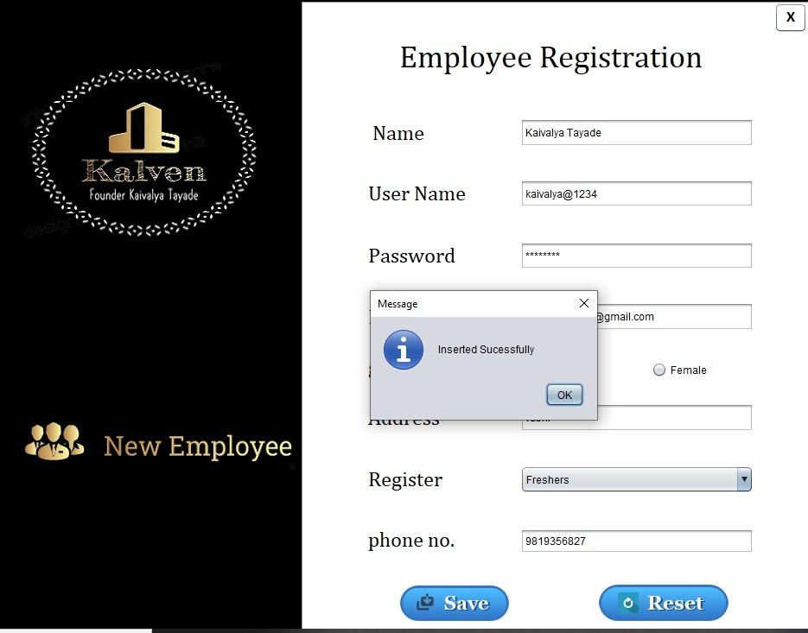

**Database**

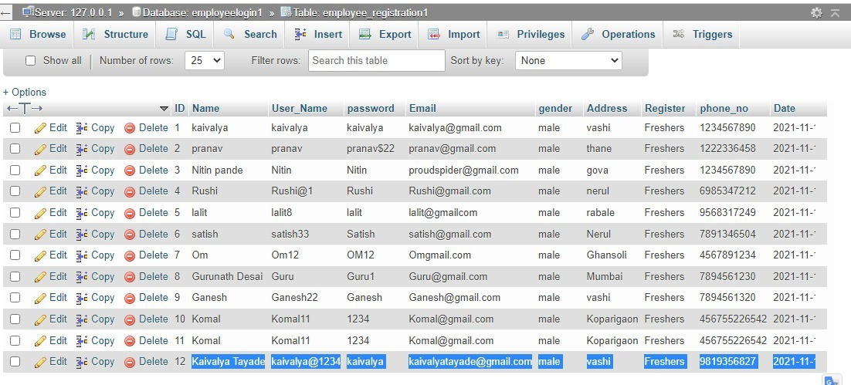

**kalvenID.java**

package employeproject1;

import java.sql.*;

import java.text.SimpleDateFormat;

import java.util.Date;

import java.util.ArrayList;

import java.util.logging.Level;

import java.util.logging.Logger;

import javax.swing.JOptionPane;

import javax.swing.table.DefaultTableModel;

public class KalvenID extends javax.swing.JFrame {

String gender;

String Date;

ResultSet rsp;

Statement st;

int lastid;

public KalvenID() {

initComponents();

//when program is run add the value of lastid for that call constrctor

getlastid();

Search.setEnabled(false);

Update.setEnabled(false);

}

public void getlastid()

{

try {

Class.forName("com.mysql.cj.jdbc.Driver");

Connection con = DriverManager.getConnection("jdbc:mysql://localhost/employeelogin1","root","");

String sql = "select max(sno) from KalvenID";

st = con.createStatement();

rsp = st.executeQuery(sql);

if(rsp.next()){

//if result set query is true then get ID from KalvenID

lastid = rsp.getInt(1);

//display the value in Jtextfeild ""

lastid++;

//convert lastID into String

sno.setText(Integer.toString(lastid));

}}

catch(Exception e){

JOptionPane.showMessageDialog(null, e);

}}

@SuppressWarnings("unchecked")

// <editor-fold defaultstate="collapsed" desc="Generated Code">

private void initComponents() {

buttonGroup1 = new javax.swing.ButtonGroup();

buttonGroup2 = new javax.swing.ButtonGroup();

jLabel13 = new javax.swing.JLabel();

jScrollPane1 = new javax.swing.JScrollPane();

jPanel1 = new javax.swing.JPanel();

jButton1 = new javax.swing.JButton();

jLabel6 = new javax.swing.JLabel();

jLabel7 = new javax.swing.JLabel();

jLabel8 = new javax.swing.JLabel();

jLabel9 = new javax.swing.JLabel();

jLabel10 = new javax.swing.JLabel();

Employee_Name = new javax.swing.JTextField();

Register_Email = new javax.swing.JTextField();

male = new javax.swing.JRadioButton();

female = new javax.swing.JRadioButton();

Day_shift = new javax.swing.JCheckBox();

Night_shift = new javax.swing.JCheckBox();

Employee_post = new javax.swing.JComboBox();

saveB = new javax.swing.JButton();

resetBtn = new javax.swing.JButton();

Salary = new javax.swing.JTextField();

jLabel11 = new javax.swing.JLabel();

jLabel12 = new javax.swing.JLabel();

jLabel15 = new javax.swing.JLabel();

Record = new javax.swing.JButton();

sno = new javax.swing.JTextField();

jLabel2 = new javax.swing.JLabel();

jLabel4 = new javax.swing.JLabel();

jLabel17 = new javax.swing.JLabel();

jPanel2 = new javax.swing.JPanel();

jLabel1 = new javax.swing.JLabel();

jLabel3 = new javax.swing.JLabel();

jLabel5 = new javax.swing.JLabel();

jPanel3 = new javax.swing.JPanel();

jSeparator1 = new javax.swing.JSeparator();

jSeparator2 = new javax.swing.JSeparator();

jPanel4 = new javax.swing.JPanel();

E_password = new javax.swing.JPasswordField();

jSeparator3 = new javax.swing.JSeparator();

E_userName = new javax.swing.JTextField();

Delete = new javax.swing.JButton();

Search = new javax.swing.JButton();

Update = new javax.swing.JButton();

jLabel16 = new javax.swing.JLabel();

jLabel18 = new javax.swing.JLabel();

jSeparator6 = new javax.swing.JSeparator();

jLabel14 = new javax.swing.JLabel();

jLabel20 = new javax.swing.JLabel();

jLabel13.setIcon(new javax.swing.ImageIcon("C:\\Users\\kaiva\\Desktop\\Employee project\\reset.jpg")); // NOI18N

setDefaultCloseOperation(javax.swing.WindowConstants.EXIT_ON_CLOSE);

setTitle("EmployeeRegister");

setUndecorated(true);

getContentPane().setLayout(new org.netbeans.lib.awtextra.AbsoluteLayout());

jScrollPane1.setEnabled(false);

jPanel1.setBackground(new java.awt.Color(255, 255, 255));

jButton1.setBackground(new java.awt.Color(255, 255, 255));

jButton1.setFont(new java.awt.Font("Calibri", 0, 18)); // NOI18N

jButton1.setText("X");

jButton1.setBorder(null);

jButton1.addActionListener(new java.awt.event.ActionListener() {

public void actionPerformed(java.awt.event.ActionEvent evt) {

jButton1ActionPerformed(evt);

}

});

jLabel6.setFont(new java.awt.Font("Calibri", 0, 24)); // NOI18N

jLabel7.setFont(new java.awt.Font("Calibri", 0, 24)); // NOI18N

jLabel7.setText("Register Email");

jLabel8.setFont(new java.awt.Font("Calibri", 0, 24)); // NOI18N

jLabel8.setText("Gender");

jLabel9.setFont(new java.awt.Font("Calibri", 0, 24)); // NOI18N

jLabel9.setText("Working Shift");

jLabel10.setFont(new java.awt.Font("Calibri", 0, 24)); // NOI18N

jLabel10.setText("Employee Categories");

Employee_Name.setFont(new java.awt.Font("Cambria Math", 1, 18)); // NOI18N

Employee_Name.addActionListener(new java.awt.event.ActionListener() {

public void actionPerformed(java.awt.event.ActionEvent evt) {

Employee_NameActionPerformed(evt);

}

});

Register_Email.setFont(new java.awt.Font("Cambria Math", 0, 18)); // NOI18N

Register_Email.addActionListener(new java.awt.event.ActionListener() {

public void actionPerformed(java.awt.event.ActionEvent evt) {

Register_EmailActionPerformed(evt);

}

});

buttonGroup1.add(male);

male.setFont(new java.awt.Font("Cambria Math", 0, 18)); // NOI18N

male.setText("Male");

male.setCursor(new java.awt.Cursor(java.awt.Cursor.DEFAULT_CURSOR));

male.addActionListener(new java.awt.event.ActionListener() {

public void actionPerformed(java.awt.event.ActionEvent evt) {

maleActionPerformed(evt);

}

});

buttonGroup1.add(female);

female.setFont(new java.awt.Font("Cambria Math", 0, 18)); // NOI18N

female.setText("Female");

female.addActionListener(new java.awt.event.ActionListener() {

public void actionPerformed(java.awt.event.ActionEvent evt) {

femaleActionPerformed(evt);

}

});

buttonGroup2.add(Day_shift);

Day_shift.setFont(new java.awt.Font("Cambria Math", 0, 18)); // NOI18N

Day_shift.setText("Day Shift");

Day_shift.addActionListener(new java.awt.event.ActionListener() {

public void actionPerformed(java.awt.event.ActionEvent evt) {

Day_shiftActionPerformed(evt);

}

});

buttonGroup2.add(Night_shift);

Night_shift.setFont(new java.awt.Font("Cambria Math", 0, 18)); // NOI18N

Night_shift.setText("Night Shift");

Night_shift.addActionListener(new java.awt.event.ActionListener() {

public void actionPerformed(java.awt.event.ActionEvent evt) {

Night_shiftActionPerformed(evt);

}

});

Employee_post.setFont(new java.awt.Font("Cambria Math", 0, 18)); // NOI18N

Employee_post.setModel(new javax.swing.DefaultComboBoxModel(new String[] { "Select ", "Project Head", "Manager", "Technician", "genral Staff", "clerk", " " }));

Employee_post.addActionListener(new java.awt.event.ActionListener() {

public void actionPerformed(java.awt.event.ActionEvent evt) {

Employee_postActionPerformed(evt);

}

});

saveB.setBackground(new java.awt.Color(51, 204, 255));

saveB.setFont(new java.awt.Font("Calibri", 0, 18)); // NOI18N

saveB.setForeground(new java.awt.Color(0, 51, 51));

saveB.setIcon(new javax.swing.ImageIcon("C:\\Users\\kaiva\\Desktop\\Employee project\\save1.png")); // NOI18N

saveB.setBorder(null);

saveB.setContentAreaFilled(false);

saveB.addActionListener(new java.awt.event.ActionListener() {

public void actionPerformed(java.awt.event.ActionEvent evt) {

saveBActionPerformed(evt);

}

});

resetBtn.setBackground(new java.awt.Color(51, 204, 255));

resetBtn.setFont(new java.awt.Font("Calibri", 0, 18)); // NOI18N

resetBtn.setForeground(new java.awt.Color(0, 51, 102));

resetBtn.setIcon(new javax.swing.ImageIcon("C:\\Users\\kaiva\\Desktop\\Employee project\\Reset1.png")); // NOI18N

resetBtn.setContentAreaFilled(false);

resetBtn.addActionListener(new java.awt.event.ActionListener() {

public void actionPerformed(java.awt.event.ActionEvent evt) {

resetBtnActionPerformed(evt);

}

});

Salary.setFont(new java.awt.Font("Cambria Math", 0, 18)); // NOI18N

Salary.setForeground(new java.awt.Color(255, 0, 0));

Salary.addActionListener(new java.awt.event.ActionListener() {

public void actionPerformed(java.awt.event.ActionEvent evt) {

SalaryActionPerformed(evt);

}

});

jLabel12.setFont(new java.awt.Font("Calibri", 0, 24)); // NOI18N

jLabel12.setText("Name");

jLabel15.setFont(new java.awt.Font("Calibri", 0, 24)); // NOI18N

jLabel15.setText("salary");

Record.setBackground(new java.awt.Color(51, 204, 255));

Record.setFont(new java.awt.Font("Calibri", 0, 18)); // NOI18N

Record.setForeground(new java.awt.Color(0, 51, 51));

Record.setIcon(new javax.swing.ImageIcon("C:\\Users\\kaiva\\Desktop\\Employee project\\Srecord1.png")); // NOI18N

Record.setContentAreaFilled(false);

Record.addActionListener(new java.awt.event.ActionListener() {

public void actionPerformed(java.awt.event.ActionEvent evt) {

RecordActionPerformed(evt);

}

});

sno.setBackground(new java.awt.Color(204, 255, 255));

sno.setFont(new java.awt.Font("Cambria Math", 1, 18)); // NOI18N

sno.setForeground(new java.awt.Color(0, 51, 153));

sno.addActionListener(new java.awt.event.ActionListener() {

public void actionPerformed(java.awt.event.ActionEvent evt) {

snoActionPerformed(evt);

}

});

sno.addKeyListener(new java.awt.event.KeyAdapter() {

public void keyPressed(java.awt.event.KeyEvent evt) {

snoKeyPressed(evt);

}

public void keyReleased(java.awt.event.KeyEvent evt) {

snoKeyReleased(evt);

}

});

jLabel2.setIcon(new javax.swing.ImageIcon("C:\\Users\\kaiva\\Desktop\\Employee project\\Rup.jpg")); // NOI18N

jLabel4.setFont(new java.awt.Font("Cambria Math", 0, 36)); // NOI18N

jLabel4.setText("Employee Record");

jLabel17.setFont(new java.awt.Font("Calibri", 0, 24)); // NOI18N

jLabel17.setText("Employee ID");

javax.swing.GroupLayout jPanel1Layout = new javax.swing.GroupLayout(jPanel1);

jPanel1.setLayout(jPanel1Layout);

jPanel1Layout.setHorizontalGroup(

jPanel1Layout.createParallelGroup(javax.swing.GroupLayout.Alignment.LEADING)

.addGroup(jPanel1Layout.createSequentialGroup()

.addGroup(jPanel1Layout.createParallelGroup(javax.swing.GroupLayout.Alignment.TRAILING)

.addGroup(jPanel1Layout.createSequentialGroup()

.addContainerGap()

.addComponent(saveB)

.addGap(14, 14, 14)

.addComponent(resetBtn, javax.swing.GroupLayout.PREFERRED_SIZE, 157, javax.swing.GroupLayout.PREFERRED_SIZE)

.addPreferredGap(javax.swing.LayoutStyle.ComponentPlacement.UNRELATED)

.addComponent(Record, javax.swing.GroupLayout.PREFERRED_SIZE, 263, javax.swing.GroupLayout.PREFERRED_SIZE))

.addGroup(jPanel1Layout.createParallelGroup(javax.swing.GroupLayout.Alignment.LEADING)

.addGroup(jPanel1Layout.createSequentialGroup()

.addGap(158, 158, 158)

.addComponent(jLabel4)

.addGap(134, 134, 134)

.addComponent(jButton1, javax.swing.GroupLayout.PREFERRED_SIZE, 45, javax.swing.GroupLayout.PREFERRED_SIZE))

.addGroup(jPanel1Layout.createSequentialGroup()

.addGap(30, 30, 30)

.addGroup(jPanel1Layout.createParallelGroup(javax.swing.GroupLayout.Alignment.LEADING)

.addGroup(jPanel1Layout.createSequentialGroup()

.addGroup(jPanel1Layout.createParallelGroup(javax.swing.GroupLayout.Alignment.LEADING)

.addComponent(jLabel12)

.addComponent(jLabel8)

.addComponent(jLabel7)

.addComponent(jLabel17)

.addComponent(jLabel9))

.addGap(112, 112, 112)

.addGroup(jPanel1Layout.createParallelGroup(javax.swing.GroupLayout.Alignment.LEADING)

.addGroup(javax.swing.GroupLayout.Alignment.TRAILING, jPanel1Layout.createParallelGroup(javax.swing.GroupLayout.Alignment.LEADING)

.addComponent(sno, javax.swing.GroupLayout.PREFERRED_SIZE, 270, javax.swing.GroupLayout.PREFERRED_SIZE)

.addComponent(Employee_Name, javax.swing.GroupLayout.PREFERRED_SIZE, 270, javax.swing.GroupLayout.PREFERRED_SIZE)

.addComponent(Register_Email, javax.swing.GroupLayout.PREFERRED_SIZE, 270, javax.swing.GroupLayout.PREFERRED_SIZE))

.addGroup(javax.swing.GroupLayout.Alignment.TRAILING, jPanel1Layout.createSequentialGroup()

.addGroup(jPanel1Layout.createParallelGroup(javax.swing.GroupLayout.Alignment.LEADING)

.addComponent(Day_shift)

.addGroup(jPanel1Layout.createSequentialGroup()

.addGap(10, 10, 10)

.addComponent(male)))

.addGap(30, 30, 30)

.addGroup(jPanel1Layout.createParallelGroup(javax.swing.GroupLayout.Alignment.LEADING)

.addComponent(female)

.addComponent(Night_shift))

.addGap(23, 23, 23))))

.addGroup(jPanel1Layout.createSequentialGroup()

.addGroup(jPanel1Layout.createParallelGroup(javax.swing.GroupLayout.Alignment.LEADING, false)

.addGroup(jPanel1Layout.createSequentialGroup()

.addComponent(jLabel10)

.addGap(39, 39, 39))

.addGroup(jPanel1Layout.createSequentialGroup()

.addComponent(jLabel15)

.addPreferredGap(javax.swing.LayoutStyle.ComponentPlacement.RELATED, javax.swing.GroupLayout.DEFAULT_SIZE, Short.MAX_VALUE)

.addComponent(jLabel2, javax.swing.GroupLayout.PREFERRED_SIZE, 45, javax.swing.GroupLayout.PREFERRED_SIZE)

.addPreferredGap(javax.swing.LayoutStyle.ComponentPlacement.RELATED)))

.addGroup(jPanel1Layout.createParallelGroup(javax.swing.GroupLayout.Alignment.LEADING, false)

.addComponent(Employee_post, 0, 270, Short.MAX_VALUE)

.addComponent(Salary)))))))

.addPreferredGap(javax.swing.LayoutStyle.ComponentPlacement.RELATED, 534, Short.MAX_VALUE)

.addGroup(jPanel1Layout.createParallelGroup(javax.swing.GroupLayout.Alignment.LEADING)

.addComponent(jLabel11, javax.swing.GroupLayout.PREFERRED_SIZE, 440, javax.swing.GroupLayout.PREFERRED_SIZE)

.addComponent(jLabel6, javax.swing.GroupLayout.PREFERRED_SIZE, 117, javax.swing.GroupLayout.PREFERRED_SIZE)))

);

jPanel1Layout.setVerticalGroup(

jPanel1Layout.createParallelGroup(javax.swing.GroupLayout.Alignment.LEADING)

.addGroup(jPanel1Layout.createSequentialGroup()

.addComponent(jLabel11)

.addPreferredGap(javax.swing.LayoutStyle.ComponentPlacement.RELATED)

.addComponent(jLabel6, javax.swing.GroupLayout.PREFERRED_SIZE, 34, javax.swing.GroupLayout.PREFERRED_SIZE)

.addContainerGap(javax.swing.GroupLayout.DEFAULT_SIZE, Short.MAX_VALUE))

.addGroup(javax.swing.GroupLayout.Alignment.TRAILING, jPanel1Layout.createSequentialGroup()

.addGroup(jPanel1Layout.createParallelGroup(javax.swing.GroupLayout.Alignment.LEADING)

.addGroup(jPanel1Layout.createSequentialGroup()

.addComponent(jButton1, javax.swing.GroupLayout.DEFAULT_SIZE, 34, Short.MAX_VALUE)

.addGap(378, 378, 378))

.addGroup(jPanel1Layout.createSequentialGroup()

.addGap(34, 34, 34)

.addComponent(jLabel4)

.addGap(39, 39, 39)

.addGroup(jPanel1Layout.createParallelGroup(javax.swing.GroupLayout.Alignment.BASELINE)

.addComponent(sno, javax.swing.GroupLayout.PREFERRED_SIZE, 35, javax.swing.GroupLayout.PREFERRED_SIZE)

.addComponent(jLabel17))

.addGap(40, 40, 40)

.addGroup(jPanel1Layout.createParallelGroup(javax.swing.GroupLayout.Alignment.TRAILING)

.addComponent(jLabel12)

.addComponent(Employee_Name, javax.swing.GroupLayout.PREFERRED_SIZE, 35, javax.swing.GroupLayout.PREFERRED_SIZE))

.addGap(42, 42, 42)

.addGroup(jPanel1Layout.createParallelGroup(javax.swing.GroupLayout.Alignment.TRAILING)

.addComponent(jLabel7)

.addComponent(Register_Email, javax.swing.GroupLayout.PREFERRED_SIZE, 34, javax.swing.GroupLayout.PREFERRED_SIZE))

.addGap(33, 33, 33)

.addGroup(jPanel1Layout.createParallelGroup(javax.swing.GroupLayout.Alignment.BASELINE)

.addComponent(jLabel8, javax.swing.GroupLayout.PREFERRED_SIZE, 44, javax.swing.GroupLayout.PREFERRED_SIZE)

.addComponent(male)

.addComponent(female))

.addPreferredGap(javax.swing.LayoutStyle.ComponentPlacement.RELATED, 32, Short.MAX_VALUE)))

.addGroup(jPanel1Layout.createParallelGroup(javax.swing.GroupLayout.Alignment.BASELINE)

.addComponent(jLabel9)

.addComponent(Day_shift)

.addComponent(Night_shift))

.addGap(37, 37, 37)

.addGroup(jPanel1Layout.createParallelGroup(javax.swing.GroupLayout.Alignment.TRAILING)

.addComponent(Employee_post, javax.swing.GroupLayout.PREFERRED_SIZE, 36, javax.swing.GroupLayout.PREFERRED_SIZE)

.addComponent(jLabel10))

.addGroup(jPanel1Layout.createParallelGroup(javax.swing.GroupLayout.Alignment.LEADING)

.addGroup(jPanel1Layout.createSequentialGroup()

.addGap(42, 42, 42)

.addComponent(jLabel15))

.addGroup(jPanel1Layout.createParallelGroup(javax.swing.GroupLayout.Alignment.LEADING)

.addGroup(javax.swing.GroupLayout.Alignment.TRAILING, jPanel1Layout.createSequentialGroup()

.addPreferredGap(javax.swing.LayoutStyle.ComponentPlacement.RELATED)

.addComponent(jLabel2, javax.swing.GroupLayout.PREFERRED_SIZE, 38, javax.swing.GroupLayout.PREFERRED_SIZE))

.addGroup(jPanel1Layout.createSequentialGroup()

.addGap(43, 43, 43)

.addComponent(Salary, javax.swing.GroupLayout.PREFERRED_SIZE, 33, javax.swing.GroupLayout.PREFERRED_SIZE))))

.addGap(50, 50, 50)

.addGroup(jPanel1Layout.createParallelGroup(javax.swing.GroupLayout.Alignment.TRAILING)

.addGroup(jPanel1Layout.createParallelGroup(javax.swing.GroupLayout.Alignment.LEADING)

.addComponent(Record)

.addComponent(resetBtn))

.addComponent(saveB, javax.swing.GroupLayout.PREFERRED_SIZE, 54, javax.swing.GroupLayout.PREFERRED_SIZE))

.addGap(801, 801, 801))

);

jScrollPane1.setViewportView(jPanel1);

getContentPane().add(jScrollPane1, new org.netbeans.lib.awtextra.AbsoluteConstraints(300, 0, 630, 760));

jPanel2.setBackground(new java.awt.Color(0, 0, 0));

jLabel1.setIcon(new javax.swing.ImageIcon("C:\\Users\\kaiva\\Desktop\\Employee project\\grow.jpeg")); // NOI18N

jLabel1.setText("jLabel1");

jLabel3.setIcon(new javax.swing.ImageIcon("C:\\Users\\kaiva\\Desktop\\Employee project\\statement2.jpeg")); // NOI18N

jLabel3.setText("jLabel3");

jLabel5.setIcon(new javax.swing.ImageIcon("C:\\Users\\kaiva\\Desktop\\Employee project\\Salary icon.jpeg")); // NOI18N

jLabel5.setText("jLabel5");

javax.swing.GroupLayout jPanel2Layout = new javax.swing.GroupLayout(jPanel2);

jPanel2.setLayout(jPanel2Layout);

jPanel2Layout.setHorizontalGroup(

jPanel2Layout.createParallelGroup(javax.swing.GroupLayout.Alignment.LEADING)

.addGroup(jPanel2Layout.createSequentialGroup()

.addContainerGap()

.addGroup(jPanel2Layout.createParallelGroup(javax.swing.GroupLayout.Alignment.LEADING)

.addComponent(jLabel1, javax.swing.GroupLayout.PREFERRED_SIZE, 0, Short.MAX_VALUE)

.addComponent(jLabel3, javax.swing.GroupLayout.PREFERRED_SIZE, 0, Short.MAX_VALUE))

.addContainerGap())

.addGroup(javax.swing.GroupLayout.Alignment.TRAILING, jPanel2Layout.createSequentialGroup()

.addContainerGap(113, Short.MAX_VALUE)

.addComponent(jLabel5, javax.swing.GroupLayout.PREFERRED_SIZE, 85, javax.swing.GroupLayout.PREFERRED_SIZE)

.addGap(102, 102, 102))

);

jPanel2Layout.setVerticalGroup(

jPanel2Layout.createParallelGroup(javax.swing.GroupLayout.Alignment.LEADING)

.addGroup(jPanel2Layout.createSequentialGroup()

.addGap(56, 56, 56)

.addComponent(jLabel1, javax.swing.GroupLayout.PREFERRED_SIZE, 209, javax.swing.GroupLayout.PREFERRED_SIZE)

.addPreferredGap(javax.swing.LayoutStyle.ComponentPlacement.RELATED, 101, Short.MAX_VALUE)

.addComponent(jLabel5, javax.swing.GroupLayout.PREFERRED_SIZE, 82, javax.swing.GroupLayout.PREFERRED_SIZE)

.addPreferredGap(javax.swing.LayoutStyle.ComponentPlacement.RELATED)

.addComponent(jLabel3, javax.swing.GroupLayout.PREFERRED_SIZE, 73, javax.swing.GroupLayout.PREFERRED_SIZE)

.addGap(233, 233, 233))

);

getContentPane().add(jPanel2, new org.netbeans.lib.awtextra.AbsoluteConstraints(0, 0, 300, 760));

javax.swing.GroupLayout jPanel3Layout = new javax.swing.GroupLayout(jPanel3);

jPanel3.setLayout(jPanel3Layout);

jPanel3Layout.setHorizontalGroup(

jPanel3Layout.createParallelGroup(javax.swing.GroupLayout.Alignment.LEADING)

.addGap(0, 620, Short.MAX_VALUE)

);

jPanel3Layout.setVerticalGroup(

jPanel3Layout.createParallelGroup(javax.swing.GroupLayout.Alignment.LEADING)

.addGap(0, 90, Short.MAX_VALUE)

);

getContentPane().add(jPanel3, new org.netbeans.lib.awtextra.AbsoluteConstraints(300, 0, 620, 90));

getContentPane().add(jSeparator1, new org.netbeans.lib.awtextra.AbsoluteConstraints(1050, 250, 200, 0));

getContentPane().add(jSeparator2, new org.netbeans.lib.awtextra.AbsoluteConstraints(1050, 240, -1, -1));

jPanel4.setBackground(new java.awt.Color(0, 0, 0));

jPanel4.setForeground(new java.awt.Color(255, 255, 255));

jPanel4.setFont(new java.awt.Font("Tahoma", 1, 18)); // NOI18N

E_password.setBackground(new java.awt.Color(0, 0, 0));

E_password.setForeground(new java.awt.Color(255, 255, 255));

E_password.setBorder(null);

E_password.addActionListener(new java.awt.event.ActionListener() {

public void actionPerformed(java.awt.event.ActionEvent evt) {

E_passwordActionPerformed(evt);

}

});

jSeparator3.setForeground(new java.awt.Color(255, 255, 255));

jSeparator3.setBorder(new javax.swing.border.LineBorder(new java.awt.Color(255, 255, 255), 3, true));

jSeparator3.setFont(new java.awt.Font("Tahoma", 1, 18)); // NOI18N

E_userName.setBackground(new java.awt.Color(0, 0, 0));

E_userName.setFont(new java.awt.Font("Cambria Math", 0, 18)); // NOI18N

E_userName.setForeground(new java.awt.Color(255, 255, 255));

E_userName.setBorder(null);

E_userName.addActionListener(new java.awt.event.ActionListener() {

public void actionPerformed(java.awt.event.ActionEvent evt) {

E_userNameActionPerformed(evt);

}

});

Delete.setBackground(new java.awt.Color(0, 102, 255));

Delete.setFont(new java.awt.Font("Cambria Math", 0, 24)); // NOI18N

Delete.setForeground(new java.awt.Color(255, 255, 255));

Delete.setText("Get Access");

Delete.addActionListener(new java.awt.event.ActionListener() {

public void actionPerformed(java.awt.event.ActionEvent evt) {

DeleteActionPerformed(evt);

}

});

Search.setBackground(new java.awt.Color(0, 0, 0));

Search.setFont(new java.awt.Font("Cambria Math", 0, 24)); // NOI18N

Search.setForeground(new java.awt.Color(255, 255, 255));

Search.setText("Search");

Search.addActionListener(new java.awt.event.ActionListener() {

public void actionPerformed(java.awt.event.ActionEvent evt) {

SearchActionPerformed(evt);

}

});

Update.setBackground(new java.awt.Color(0, 0, 0));

Update.setFont(new java.awt.Font("Cambria Math", 0, 24)); // NOI18N

Update.setForeground(new java.awt.Color(255, 255, 255));

Update.setText("Update");

Update.addActionListener(new java.awt.event.ActionListener() {

public void actionPerformed(java.awt.event.ActionEvent evt) {

UpdateActionPerformed(evt);

}

});

jLabel16.setFont(new java.awt.Font("Calibri", 0, 24)); // NOI18N

jLabel16.setForeground(new java.awt.Color(255, 255, 255));

jLabel16.setText("Admin Name");

jLabel18.setFont(new java.awt.Font("Calibri", 0, 24)); // NOI18N

jLabel18.setForeground(new java.awt.Color(255, 255, 255));

jLabel18.setText("Password");

jSeparator6.setForeground(new java.awt.Color(255, 255, 255));

jSeparator6.setBorder(new javax.swing.border.LineBorder(new java.awt.Color(255, 255, 255), 3, true));

jSeparator6.setFont(new java.awt.Font("Tahoma", 1, 18)); // NOI18N

jLabel14.setIcon(new javax.swing.ImageIcon("C:\\Users\\kaiva\\Desktop\\Employee access\\acess Symbol.PNG")); // NOI18N

jLabel14.setText("jLabel14");

jLabel20.setIcon(new javax.swing.ImageIcon("C:\\Users\\kaiva\\Desktop\\Employee access\\assceekk.PNG")); // NOI18N

jLabel20.setText("jLabel20");

javax.swing.GroupLayout jPanel4Layout = new javax.swing.GroupLayout(jPanel4);

jPanel4.setLayout(jPanel4Layout);

jPanel4Layout.setHorizontalGroup(

jPanel4Layout.createParallelGroup(javax.swing.GroupLayout.Alignment.LEADING)

.addGroup(jPanel4Layout.createSequentialGroup()

.addContainerGap(javax.swing.GroupLayout.DEFAULT_SIZE, Short.MAX_VALUE)

.addGroup(jPanel4Layout.createParallelGroup(javax.swing.GroupLayout.Alignment.LEADING, false)

.addGroup(javax.swing.GroupLayout.Alignment.TRAILING, jPanel4Layout.createSequentialGroup()

.addGroup(jPanel4Layout.createParallelGroup(javax.swing.GroupLayout.Alignment.LEADING)

.addComponent(Delete, javax.swing.GroupLayout.PREFERRED_SIZE, 193, javax.swing.GroupLayout.PREFERRED_SIZE)

.addGroup(jPanel4Layout.createParallelGroup(javax.swing.GroupLayout.Alignment.TRAILING)

.addComponent(Search, javax.swing.GroupLayout.PREFERRED_SIZE, 190, javax.swing.GroupLayout.PREFERRED_SIZE)

.addComponent(Update, javax.swing.GroupLayout.PREFERRED_SIZE, 190, javax.swing.GroupLayout.PREFERRED_SIZE)))

.addGap(104, 104, 104))

.addGroup(javax.swing.GroupLayout.Alignment.TRAILING, jPanel4Layout.createSequentialGroup()

.addGroup(jPanel4Layout.createParallelGroup(javax.swing.GroupLayout.Alignment.TRAILING)

.addComponent(jSeparator6, javax.swing.GroupLayout.PREFERRED_SIZE, 234, javax.swing.GroupLayout.PREFERRED_SIZE)

.addComponent(E_userName, javax.swing.GroupLayout.PREFERRED_SIZE, 234, javax.swing.GroupLayout.PREFERRED_SIZE)

.addGroup(jPanel4Layout.createSequentialGroup()

.addGap(13, 13, 13)

.addComponent(jLabel18)

.addPreferredGap(javax.swing.LayoutStyle.ComponentPlacement.RELATED, javax.swing.GroupLayout.DEFAULT_SIZE, Short.MAX_VALUE)

.addGroup(jPanel4Layout.createParallelGroup(javax.swing.GroupLayout.Alignment.LEADING)

.addComponent(jSeparator3, javax.swing.GroupLayout.Alignment.TRAILING, javax.swing.GroupLayout.PREFERRED_SIZE, 234, javax.swing.GroupLayout.PREFERRED_SIZE)

.addComponent(E_password, javax.swing.GroupLayout.Alignment.TRAILING, javax.swing.GroupLayout.PREFERRED_SIZE, 234, javax.swing.GroupLayout.PREFERRED_SIZE))))

.addGap(61, 61, 61))

.addGroup(javax.swing.GroupLayout.Alignment.TRAILING, jPanel4Layout.createSequentialGroup()

.addComponent(jLabel16, javax.swing.GroupLayout.PREFERRED_SIZE, 129, javax.swing.GroupLayout.PREFERRED_SIZE)

.addGap(322, 322, 322))

.addGroup(jPanel4Layout.createSequentialGroup()

.addComponent(jLabel14, javax.swing.GroupLayout.PREFERRED_SIZE, 112, javax.swing.GroupLayout.PREFERRED_SIZE)

.addPreferredGap(javax.swing.LayoutStyle.ComponentPlacement.RELATED)

.addComponent(jLabel20, javax.swing.GroupLayout.PREFERRED_SIZE, 267, javax.swing.GroupLayout.PREFERRED_SIZE)

.addGap(66, 66, 66))))

);

jPanel4Layout.setVerticalGroup(

jPanel4Layout.createParallelGroup(javax.swing.GroupLayout.Alignment.LEADING)

.addGroup(jPanel4Layout.createSequentialGroup()

.addGap(19, 19, 19)

.addGroup(jPanel4Layout.createParallelGroup(javax.swing.GroupLayout.Alignment.BASELINE)

.addComponent(jLabel14)

.addComponent(jLabel20, javax.swing.GroupLayout.PREFERRED_SIZE, 67, javax.swing.GroupLayout.PREFERRED_SIZE))

.addGap(35, 35, 35)

.addGroup(jPanel4Layout.createParallelGroup(javax.swing.GroupLayout.Alignment.BASELINE)

.addComponent(E_userName, javax.swing.GroupLayout.PREFERRED_SIZE, 30, javax.swing.GroupLayout.PREFERRED_SIZE)

.addComponent(jLabel16))

.addPreferredGap(javax.swing.LayoutStyle.ComponentPlacement.RELATED)

.addComponent(jSeparator6, javax.swing.GroupLayout.PREFERRED_SIZE, 5, javax.swing.GroupLayout.PREFERRED_SIZE)

.addGap(34, 34, 34)

.addGroup(jPanel4Layout.createParallelGroup(javax.swing.GroupLayout.Alignment.TRAILING)

.addComponent(jLabel18)

.addGroup(jPanel4Layout.createSequentialGroup()

.addComponent(E_password, javax.swing.GroupLayout.PREFERRED_SIZE, 30, javax.swing.GroupLayout.PREFERRED_SIZE)

.addPreferredGap(javax.swing.LayoutStyle.ComponentPlacement.RELATED)

.addComponent(jSeparator3, javax.swing.GroupLayout.PREFERRED_SIZE, 5, javax.swing.GroupLayout.PREFERRED_SIZE)))

.addPreferredGap(javax.swing.LayoutStyle.ComponentPlacement.RELATED, 77, Short.MAX_VALUE)

.addComponent(Delete, javax.swing.GroupLayout.PREFERRED_SIZE, 60, javax.swing.GroupLayout.PREFERRED_SIZE)

.addGap(68, 68, 68)

.addComponent(Search, javax.swing.GroupLayout.PREFERRED_SIZE, 60, javax.swing.GroupLayout.PREFERRED_SIZE)

.addGap(67, 67, 67)

.addComponent(Update, javax.swing.GroupLayout.PREFERRED_SIZE, 60, javax.swing.GroupLayout.PREFERRED_SIZE)

.addGap(82, 82, 82))

);

getContentPane().add(jPanel4, new org.netbeans.lib.awtextra.AbsoluteConstraints(930, 0, 440, 760));

setSize(new java.awt.Dimension(1356, 1126));

setLocationRelativeTo(null);

}// </editor-fold>

private void jButton1ActionPerformed(java.awt.event.ActionEvent evt) {

dispose();

}

private void Day_shiftActionPerformed(java.awt.event.ActionEvent evt) {

// TODO add your handling code here:

}

private void Night_shiftActionPerformed(java.awt.event.ActionEvent evt) {

// TODO add your handling code here:

}

private void Employee_NameActionPerformed(java.awt.event.ActionEvent evt) {

// TODO add your handling code here:

}

private void maleActionPerformed(java.awt.event.ActionEvent evt) {

// TODO add your handling code here:

}

private void femaleActionPerformed(java.awt.event.ActionEvent evt) {

// TODO add your handling code here:

}

private void Employee_postActionPerformed(java.awt.event.ActionEvent evt) {

// TODO add your handling code here:

}

private void Register_EmailActionPerformed(java.awt.event.ActionEvent evt) {

// TODO add your handling code here:

}

private void saveBActionPerformed(java.awt.event.ActionEvent evt) {

try {

Class.forName("com.mysql.cj.jdbc.Driver");

Connection con = DriverManager.getConnection("jdbc:mysql://localhost/employeelogin1","root","");

String query = "insert into KalvenID(Employee_Name,Register_Email,Gender,Work_Shift,Employee_post,Salary,Date)values(?,?,?,?,?,?,?);";

PreparedStatement pst = con.prepareStatement(query);

pst.setString(1, Employee_Name.getText());

pst.setString(2, Register_Email.getText());

if(male.isSelected()){

gender="Male";

}

if(female.isSelected()){

gender="Female";

}

pst.setString(3, gender);

String shift="";

if(Day_shift.isSelected()){

shift+=Day_shift.getText()+" ";

}

if(Night_shift.isSelected()){

shift+=Night_shift.getText()+" ";

}

pst.setString(4, shift);

String post;

post = Employee_post.getSelectedItem().toString();

pst.setString(5, post);

pst.setString(6, Salary.getText());

pst.setDate(7, new java.sql.Date(System.currentTimeMillis()));

pst.executeUpdate();

JOptionPane.showMessageDialog(null, "Inserted Sucessfully");

}

catch(Exception e){

JOptionPane.showMessageDialog(null, e);

}

private void SalaryActionPerformed(java.awt.event.ActionEvent evt) {

// TODO add your handling code here:

}

private void resetBtnActionPerformed(java.awt.event.ActionEvent evt) {

Employee_Name.setText("");

Register_Email.setText("");

buttonGroup1.clearSelection();

buttonGroup2.clearSelection();

Employee_post.setSelectedIndex(0);

Salary.setText("");

}

private void GetAccessActionPerformed(java.awt.event.ActionEvent evt) {

String user = E_userName.getText();

String pa = E_password.getText();

try {

Class.forName("com.mysql.cj.jdbc.Driver");

Connection conn = DriverManager.getConnection("jdbc:mysql://localhost/employeelogin1","root","");

Statement stmt = conn.createStatement();

ResultSet rs = stmt.executeQuery("select * from admin_access");

while(rs.next()){

String User_Name = rs.getString(1);

String Password = rs.getString(2);

if(user.equals(User_Name) && pa.equals(Password)){

JOptionPane.showMessageDialog(null," permission granted");

Search.setEnabled(true);

Update.setEnabled(true);

}

else{

JOptionPane.showMessageDialog(null,"permission denied");

dispose();

} }}

catch(Exception e){

JOptionPane.showMessageDialog(null, e);

}

}

private void RecordActionPerformed(java.awt.event.ActionEvent evt) {

// TODO add your handling code here:

SalaryRecord sl = new SalaryRecord();

sl.setVisible(true);

}

private void SearchActionPerformed(java.awt.event.ActionEvent evt) {

try {

Class.forName("com.mysql.cj.jdbc.Driver");

Connection conn = DriverManager.getConnection("jdbc:mysql://localhost/employeelogin1","root","");

String sql = "select * from KalvenID where sno =?";

PreparedStatement pstmt = conn.prepareStatement(sql);

pstmt.setInt(1,Integer.parseInt(sno.getText()));

ResultSet rs = pstmt.executeQuery();

if(rs.next())

{

String setid = rs.getString("sno");

sno.setText(setid);

String setname = rs.getString("Employee_Name");

Employee_Name.setText(setname);

String setadd = rs.getString("Register_Email");

Register_Email.setText(setadd);

//create a variable sex

String sex = rs.getString("Gender");

if(sex.equals("Male")){

male.setSelected(true);

}

else{

female.setSelected(true);

}

String shift =rs.getString("Employee_post");

switch(shift){

case "Day_Shift ":

Day_shift.setSelected(true);

Night_shift.setSelected(false);

break;

case "Night_shift ":

Night_shift.setSelected(true);

Day_shift.setSelected(false);

break;

default:

Day_shift.setSelected(true);

Night_shift.setSelected(false);

break;

}

String post1 = rs.getString("Employee_post");

switch(post1){

case "Select":

Employee_post.setSelectedIndex(0);

break;

case "Project Head":

Employee_post.setSelectedIndex(1);

break;

case "Manager":

Employee_post.setSelectedIndex(2);

break;

case "Technician":

Employee_post.setSelectedIndex(3);

break;

case "genral Staff":

Employee_post.setSelectedIndex(4);

break;

case "clerk":

Employee_post.setSelectedIndex(5);

break;

}

String salary1 = rs.getString("Salary");

Salary.setText(salary1);

} }

catch(Exception e){

JOptionPane.showMessageDialog(null, e);

}}

private void snoActionPerformed(java.awt.event.ActionEvent evt) {

// TODO add your handling code here:

}

private void snoKeyPressed(java.awt.event.KeyEvent evt) {

}

private void snoKeyReleased(java.awt.event.KeyEvent evt) {

String PATTERN ="^[0-9]{0,2}$";

Pattern patt=Pattern.compile(PATTERN);

Matcher match=patt.matcher(sno.getText());

if(!match.matches()){

ID.setText("Invalide Employee ID!");

}

else{

ID.setText(null);

} }

private void UpdateActionPerformed(java.awt.event.ActionEvent evt) {

try {

Class.forName("com.mysql.cj.jdbc.Driver");

Connection conn = DriverManager.getConnection("jdbc:mysql://localhost/employeelogin1","root","");

//Gives SQL Update command

String sql = "update KalvenID set Employee_Name=?, Register_Email=?, Gender=?, Work_Shift=?, Employee_post=?, Salary=? where sno=?";

PreparedStatement pstmt = conn.prepareStatement(sql);

pstmt.setString(1, Employee_Name.getText());

pstmt.setString(2, Register_Email.getText());

if(male.isSelected()){

gender="Male";

}

if(female.isSelected()){

gender="Female";

}

pstmt.setString(3, gender);

String shift="";

if(Day_shift.isSelected()){

shift+=Day_shift.getText()+" ";

}

if(Night_shift.isSelected()){

shift+=Night_shift.getText()+" ";

}

pstmt.setString(4, shift);

String post;

post = Employee_post.getSelectedItem().toString();

pstmt.setString(5, post);

pstmt.setString(6, Salary.getText());

pstmt.setInt(7, Integer.parseInt(sno.getText()));

pstmt.executeUpdate();

JOptionPane.showMessageDialog(null, "Record Updated Sucessfully");

}

catch(Exception e){

JOptionPane.showMessageDialog(null, e);

} }

private void E_userNameActionPerformed(java.awt.event.ActionEvent evt) {

// TODO add your handling code here:

}

private void E_passwordActionPerformed(java.awt.event.ActionEvent evt) {

// TODO add your handling code here:

}

private void Employee_NameKeyReleased(java.awt.event.KeyEvent evt) {

String PATTERN ="[0-9]{0,30}";

Pattern patt=Pattern.compile(PATTERN);

Matcher match=patt.matcher(Employee_Name.getText());

if(match.matches()){

NAME.setText("Incorrect Name!");

}

else{

NAME.setText(null);

}

private void Register_EmailKeyReleased(java.awt.event.KeyEvent evt) {

String PATTERN ="^[a-zA-Z0-9]{2,30}+[@][a-zA-Z0-9]{2,10}[.][a-zA-Z]{2,5}$";

Pattern patt=Pattern.compile(PATTERN);

Matcher match=patt.matcher(Register_Email.getText());

if(!match.matches()){

EMAIL.setText("Incorrect Email!");

}

else{

EMAIL.setText(null);

}

}

private void SalaryKeyReleased(java.awt.event.KeyEvent evt) {

// TODO add your handling code here:

String PATTERN ="^[0-9]{0,5}$";

Pattern patt=Pattern.compile(PATTERN);

Matcher match=patt.matcher(Salary.getText());

if(!match.matches()){

SALARY.setText("please Enter the correct received Salary !");

}

else{

SALARY.setText(null);

}}

public static void main(String args[]) {

for (javax.swing.UIManager.LookAndFeelInfo info : javax.swing.UIManager.getInstalledLookAndFeels()) {

if ("Nimbus".equals(info.getName())) {

javax.swing.UIManager.setLookAndFeel(info.getClassName());

break;

}}

} catch (ClassNotFoundException ex) {

java.util.logging.Logger.getLogger(KalvenID.class.getName()).log(java.util.logging.Level.SEVERE, null, ex);

} catch (InstantiationException ex) {

java.util.logging.Logger.getLogger(KalvenID.class.getName()).log(java.util.logging.Level.SEVERE, null, ex);

} catch (IllegalAccessException ex) {

java.util.logging.Logger.getLogger(KalvenID.class.getName()).log(java.util.logging.Level.SEVERE, null, ex);

} catch (javax.swing.UnsupportedLookAndFeelException ex) {

java.util.logging.Logger.getLogger(KalvenID.class.getName()).log(java.util.logging.Level.SEVERE, null, ex);

}

//</editor-fold>

/* Create and display the form */

java.awt.EventQueue.invokeLater(new Runnable() {

public void run() {

new KalvenID().setVisible(true);

}

});

}

// Variables declaration - do not modify

private javax.swing.JCheckBox Day_shift;

private javax.swing.JButton Delete;

private javax.swing.JPasswordField E_password;

private javax.swing.JTextField E_userName;

private javax.swing.JTextField Employee_Name;

private javax.swing.JComboBox Employee_post;

private javax.swing.JCheckBox Night_shift;

private javax.swing.JButton Record;

private javax.swing.JTextField Register_Email;

private javax.swing.JTextField Salary;

private javax.swing.JButton Search;

private javax.swing.JButton Update;

private javax.swing.ButtonGroup buttonGroup1;

private javax.swing.ButtonGroup buttonGroup2;

private javax.swing.JRadioButton female;

private javax.swing.JButton jButton1;

private javax.swing.JLabel jLabel1;

private javax.swing.JLabel jLabel10;

private javax.swing.JLabel jLabel11;

private javax.swing.JLabel jLabel12;

private javax.swing.JLabel jLabel13;

private javax.swing.JLabel jLabel14;

private javax.swing.JLabel jLabel15;

private javax.swing.JLabel jLabel16;

private javax.swing.JLabel jLabel17;

private javax.swing.JLabel jLabel18;

private javax.swing.JLabel jLabel2;

private javax.swing.JLabel jLabel20;

private javax.swing.JLabel jLabel3;

private javax.swing.JLabel jLabel4;

private javax.swing.JLabel jLabel5;

private javax.swing.JLabel jLabel6;

private javax.swing.JLabel jLabel7;

private javax.swing.JLabel jLabel8;

private javax.swing.JLabel jLabel9;

private javax.swing.JPanel jPanel1;

private javax.swing.JPanel jPanel2;

private javax.swing.JPanel jPanel3;

private javax.swing.JPanel jPanel4;

private javax.swing.JScrollPane jScrollPane1;

private javax.swing.JSeparator jSeparator1;

private javax.swing.JSeparator jSeparator2;

private javax.swing.JSeparator jSeparator3;

private javax.swing.JSeparator jSeparator6;

private javax.swing.JRadioButton male;

private javax.swing.JButton resetBtn;

private javax.swing.JButton saveB;

private javax.swing.JTextField sno;

// End of variables declaration

}

**Output**

**Click on Get Access button**

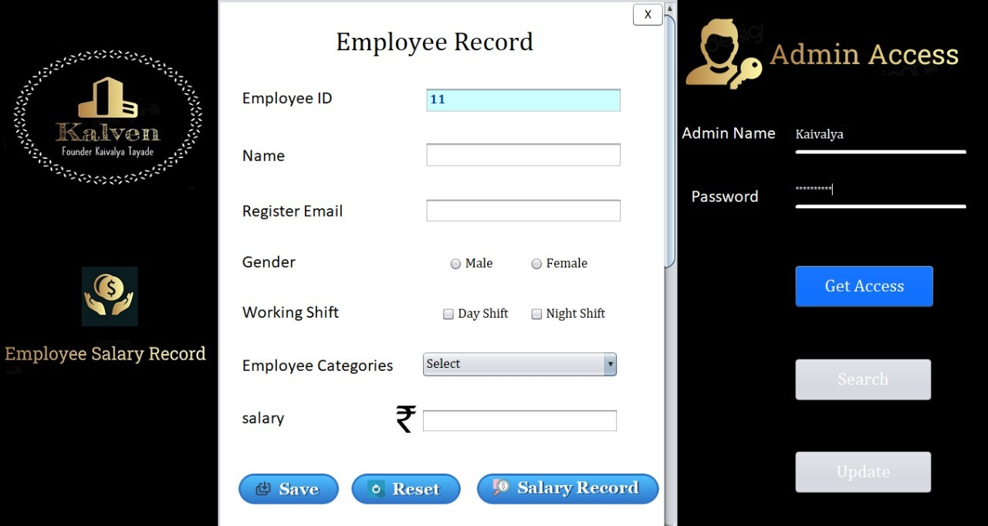

* Now, Admin can **Search** & **Update** Record

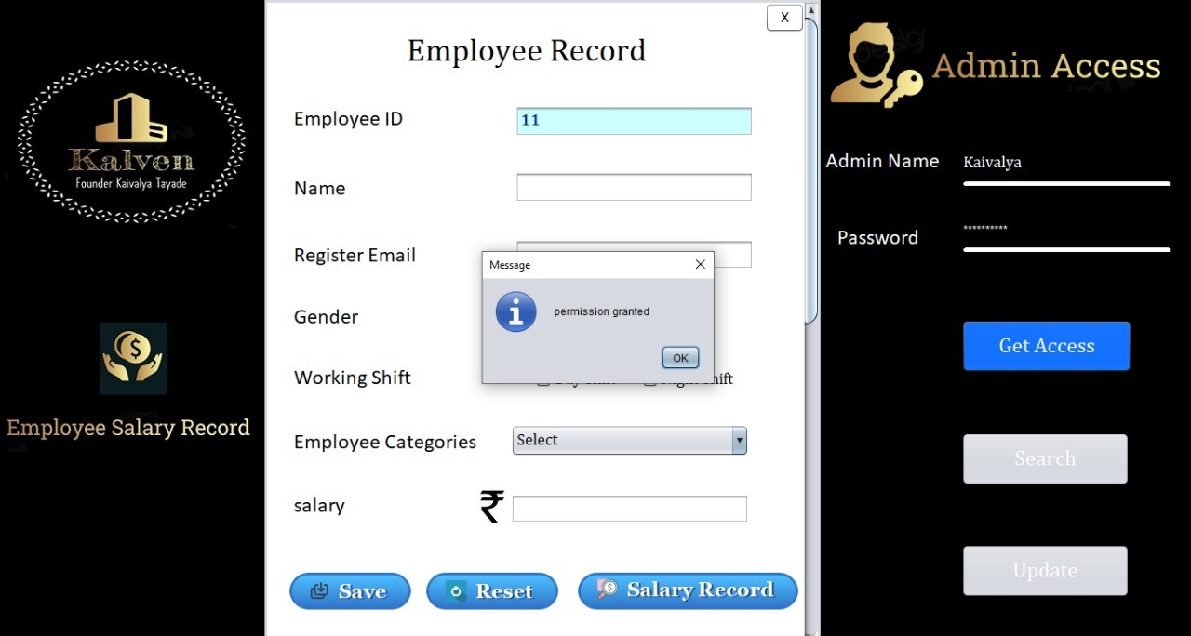

**Click on Update button**

**Click on Reset button all record become empty to reinsert record**

**Click on Save button for save the record**

**Click on ID button for search the record**

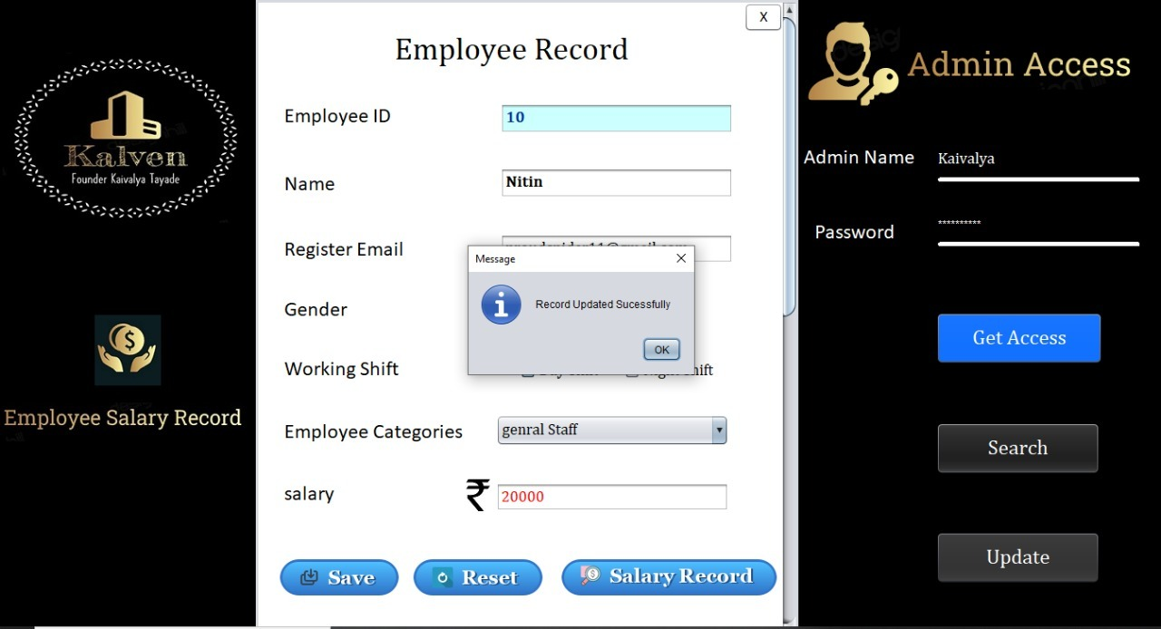

**Database**

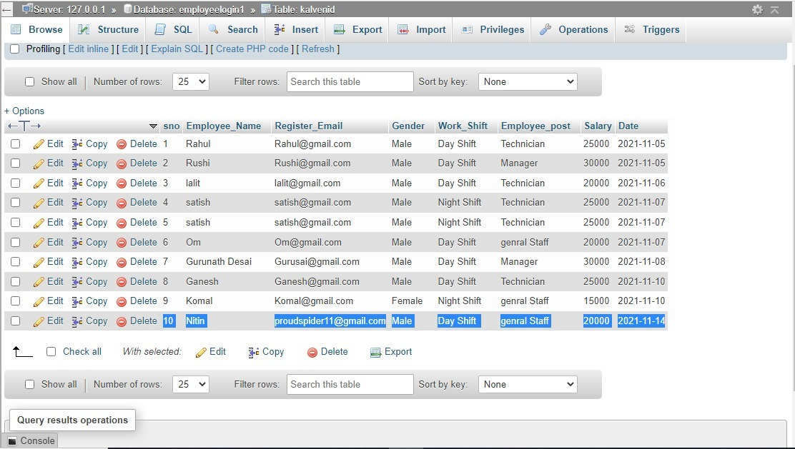

**SalaryRecord.java**

package employeproject1;

import java.sql.Connection;

import java.sql.DriverManager;

import java.sql.PreparedStatement;

import java.sql.ResultSet;

import java.sql.Statement;

import javax.swing.JOptionPane;

import javax.swing.table.DefaultTableModel;

public class SalaryRecord extends javax.swing.JFrame {

String gender;

public SalaryRecord() {

initComponents();

}

@SuppressWarnings("unchecked")

// <editor-fold defaultstate="collapsed" desc="Generated Code">

private void initComponents() {

Close = new javax.swing.JButton();

jPanel2 = new javax.swing.JPanel();

jLabel1 = new javax.swing.JLabel();

jLabel2 = new javax.swing.JLabel();

jLabel3 = new javax.swing.JLabel();

jPanel3 = new javax.swing.JPanel();

jLabel4 = new javax.swing.JLabel();

jScrollPane1 = new javax.swing.JScrollPane();

ERecord = new javax.swing.JTable();

ShowData = new javax.swing.JButton();

jButton1 = new javax.swing.JButton();

Head = new javax.swing.JButton();

Head1 = new javax.swing.JButton();

Head2 = new javax.swing.JButton();

Head3 = new javax.swing.JButton();

jLabel5 = new javax.swing.JLabel();

Close.setBackground(new java.awt.Color(255, 255, 255));

Close.setFont(new java.awt.Font("Cambria Math", 0, 18)); // NOI18N

Close.setText("X");

Close.setBorder(null);

Close.addActionListener(new java.awt.event.ActionListener() {

public void actionPerformed(java.awt.event.ActionEvent evt) {

CloseActionPerformed(evt);

}

});

setDefaultCloseOperation(javax.swing.WindowConstants.EXIT_ON_CLOSE);

setUndecorated(true);

getContentPane().setLayout(new org.netbeans.lib.awtextra.AbsoluteLayout());

jPanel2.setBackground(new java.awt.Color(0, 0, 0));

jLabel1.setIcon(new javax.swing.ImageIcon("C:\\Users\\kaiva\\Desktop\\project files\\kaivalya.jpg")); // NOI18N

jLabel1.setText("jLabel1");

jLabel2.setIcon(new javax.swing.ImageIcon("C:\\Users\\kaiva\\Desktop\\Employee project\\Salary icon.jpeg")); // NOI18N

jLabel2.setText("jLabel2");

jLabel3.setIcon(new javax.swing.ImageIcon("C:\\Users\\kaiva\\Desktop\\Employee project\\statement2.jpeg")); // NOI18N

jLabel3.setText("jLabel3");

jPanel3.setBackground(new java.awt.Color(255, 255, 255));

jLabel4.setBackground(new java.awt.Color(51, 255, 255));

jLabel4.setFont(new java.awt.Font("Cambria Math", 0, 36)); // NOI18N

jLabel4.setText("Employee Salary Record");

ERecord.setModel(new javax.swing.table.DefaultTableModel(

new Object [][] {

},

new String [] {

"Sno", "Employee_Name", "Register_Email", "Gender", "Work_Shift", "Employee_Post", "Salary", "Date"

}

));

jScrollPane1.setViewportView(ERecord);

ShowData.setBackground(new java.awt.Color(0, 51, 102));

ShowData.setFont(new java.awt.Font("Cambria Math", 0, 24)); // NOI18N

ShowData.setForeground(new java.awt.Color(255, 255, 255));

ShowData.setIcon(new javax.swing.ImageIcon("C:\\Users\\kaiva\\Desktop\\Employee access\\Display2.png")); // NOI18N

ShowData.setBorder(new javax.swing.border.LineBorder(new java.awt.Color(255, 255, 255), 1, true));

ShowData.setContentAreaFilled(false);

ShowData.addActionListener(new java.awt.event.ActionListener() {

public void actionPerformed(java.awt.event.ActionEvent evt) {

ShowDataActionPerformed(evt);

}

});

jButton1.setBackground(new java.awt.Color(255, 255, 255));

jButton1.setFont(new java.awt.Font("Cambria Math", 0, 24)); // NOI18N

jButton1.setText("X");

jButton1.setActionCommand("");

jButton1.addActionListener(new java.awt.event.ActionListener() {

public void actionPerformed(java.awt.event.ActionEvent evt) {

jButton1ActionPerformed(evt);

}

});

javax.swing.GroupLayout jPanel3Layout = new javax.swing.GroupLayout(jPanel3);

jPanel3.setLayout(jPanel3Layout);

jPanel3Layout.setHorizontalGroup(

jPanel3Layout.createParallelGroup(javax.swing.GroupLayout.Alignment.LEADING)

.addGroup(javax.swing.GroupLayout.Alignment.TRAILING, jPanel3Layout.createSequentialGroup()

.addGap(0, 0, Short.MAX_VALUE)

.addComponent(jButton1))

.addGroup(jPanel3Layout.createSequentialGroup()

.addGroup(jPanel3Layout.createParallelGroup(javax.swing.GroupLayout.Alignment.LEADING)

.addGroup(jPanel3Layout.createSequentialGroup()

.addGap(138, 138, 138)

.addComponent(jLabel4))

.addGroup(jPanel3Layout.createSequentialGroup()

.addGap(21, 21, 21)

.addGroup(jPanel3Layout.createParallelGroup(javax.swing.GroupLayout.Alignment.LEADING)

.addComponent(ShowData, javax.swing.GroupLayout.PREFERRED_SIZE, 267, javax.swing.GroupLayout.PREFERRED_SIZE)

.addComponent(jScrollPane1, javax.swing.GroupLayout.PREFERRED_SIZE, 625, javax.swing.GroupLayout.PREFERRED_SIZE))))

.addContainerGap(30, Short.MAX_VALUE))

);

jPanel3Layout.setVerticalGroup(

jPanel3Layout.createParallelGroup(javax.swing.GroupLayout.Alignment.LEADING)

.addGroup(jPanel3Layout.createSequentialGroup()

.addComponent(jButton1, javax.swing.GroupLayout.PREFERRED_SIZE, 37, javax.swing.GroupLayout.PREFERRED_SIZE)

.addGap(35, 35, 35)

.addComponent(jLabel4)

.addGap(90, 90, 90)

.addComponent(jScrollPane1, javax.swing.GroupLayout.PREFERRED_SIZE, 251, javax.swing.GroupLayout.PREFERRED_SIZE)

.addGap(40, 40, 40)

.addComponent(ShowData, javax.swing.GroupLayout.PREFERRED_SIZE, 62, javax.swing.GroupLayout.PREFERRED_SIZE)

.addContainerGap(javax.swing.GroupLayout.DEFAULT_SIZE, Short.MAX_VALUE))

);

javax.swing.GroupLayout jPanel2Layout = new javax.swing.GroupLayout(jPanel2);

jPanel2.setLayout(jPanel2Layout);

jPanel2Layout.setHorizontalGroup(

jPanel2Layout.createParallelGroup(javax.swing.GroupLayout.Alignment.LEADING)

.addGroup(jPanel2Layout.createSequentialGroup()

.addGroup(jPanel2Layout.createParallelGroup(javax.swing.GroupLayout.Alignment.LEADING)

.addGroup(jPanel2Layout.createSequentialGroup()

.addContainerGap()

.addGroup(jPanel2Layout.createParallelGroup(javax.swing.GroupLayout.Alignment.LEADING)

.addComponent(jLabel3, javax.swing.GroupLayout.Alignment.TRAILING, javax.swing.GroupLayout.PREFERRED_SIZE, 283, javax.swing.GroupLayout.PREFERRED_SIZE)

.addComponent(jLabel1, javax.swing.GroupLayout.PREFERRED_SIZE, 273, javax.swing.GroupLayout.PREFERRED_SIZE)))

.addGroup(jPanel2Layout.createSequentialGroup()

.addGap(103, 103, 103)

.addComponent(jLabel2, javax.swing.GroupLayout.PREFERRED_SIZE, 73, javax.swing.GroupLayout.PREFERRED_SIZE)))

.addGap(11, 11, 11)

.addComponent(jPanel3, javax.swing.GroupLayout.DEFAULT_SIZE, javax.swing.GroupLayout.DEFAULT_SIZE, Short.MAX_VALUE))

);

jPanel2Layout.setVerticalGroup(

jPanel2Layout.createParallelGroup(javax.swing.GroupLayout.Alignment.LEADING)

.addGroup(jPanel2Layout.createSequentialGroup()

.addGap(21, 21, 21)

.addComponent(jLabel1, javax.swing.GroupLayout.PREFERRED_SIZE, 231, javax.swing.GroupLayout.PREFERRED_SIZE)

.addGap(145, 145, 145)

.addComponent(jLabel2, javax.swing.GroupLayout.PREFERRED_SIZE, 66, javax.swing.GroupLayout.PREFERRED_SIZE)

.addPreferredGap(javax.swing.LayoutStyle.ComponentPlacement.UNRELATED)

.addComponent(jLabel3, javax.swing.GroupLayout.PREFERRED_SIZE, 38, javax.swing.GroupLayout.PREFERRED_SIZE)

.addContainerGap(681, Short.MAX_VALUE))

.addComponent(jPanel3, javax.swing.GroupLayout.Alignment.TRAILING, javax.swing.GroupLayout.DEFAULT_SIZE, javax.swing.GroupLayout.DEFAULT_SIZE, Short.MAX_VALUE)

);

getContentPane().add(jPanel2, new org.netbeans.lib.awtextra.AbsoluteConstraints(0, 0, 980, -1));

Head.setBackground(new java.awt.Color(0, 0, 0));

Head.setFont(new java.awt.Font("Cambria Math", 0, 24)); // NOI18N

Head.setForeground(new java.awt.Color(255, 255, 255));

Head.setText("Manager");

Head.addActionListener(new java.awt.event.ActionListener() {

public void actionPerformed(java.awt.event.ActionEvent evt) {

HeadActionPerformed(evt);

}

});

getContentPane().add(Head, new org.netbeans.lib.awtextra.AbsoluteConstraints(1090, 290, 200, 60));

Head1.setBackground(new java.awt.Color(0, 0, 0));

Head1.setFont(new java.awt.Font("Cambria Math", 0, 24)); // NOI18N

Head1.setForeground(new java.awt.Color(255, 255, 255));

Head1.setText("Add Record");

Head1.addActionListener(new java.awt.event.ActionListener() {

public void actionPerformed(java.awt.event.ActionEvent evt) {

Head1ActionPerformed(evt);

}

});

getContentPane().add(Head1, new org.netbeans.lib.awtextra.AbsoluteConstraints(1090, 560, 200, 60));

Head2.setBackground(new java.awt.Color(0, 0, 0));

Head2.setFont(new java.awt.Font("Cambria Math", 0, 24)); // NOI18N

Head2.setForeground(new java.awt.Color(255, 255, 255));

Head2.setText("Project Head");

Head2.addActionListener(new java.awt.event.ActionListener() {

public void actionPerformed(java.awt.event.ActionEvent evt) {

Head2ActionPerformed(evt);

}

});

getContentPane().add(Head2, new org.netbeans.lib.awtextra.AbsoluteConstraints(1090, 160, 200, 60));

Head3.setBackground(new java.awt.Color(0, 0, 0));

Head3.setFont(new java.awt.Font("Cambria Math", 0, 24)); // NOI18N

Head3.setForeground(new java.awt.Color(255, 255, 255));

Head3.setText(" Registration");

Head3.addActionListener(new java.awt.event.ActionListener() {

public void actionPerformed(java.awt.event.ActionEvent evt) {

Head3ActionPerformed(evt);

}

});

getContentPane().add(Head3, new org.netbeans.lib.awtextra.AbsoluteConstraints(1090, 420, 200, 60));

jLabel5.setIcon(new javax.swing.ImageIcon("C:\\Users\\kaiva\\Desktop\\Employee project\\make1.jpeg")); // NOI18N

getContentPane().add(jLabel5, new org.netbeans.lib.awtextra.AbsoluteConstraints(980, 0, 420, 770));

pack();

}// </editor-fold>

private void ShowDataActionPerformed(java.awt.event.ActionEvent evt) {

//Database connection

try {

Class.forName("com.mysql.cj.jdbc.Driver");

Connection con = DriverManager.getConnection("jdbc:mysql://localhost/employeelogin1","root","");

Statement st = con.createStatement();

//mysql query

String sql= "select * from KalvenID";

ResultSet rs = st.executeQuery(sql);

while(rs.next()){

//data will be added until the finish

String sno = String.valueOf(rs.getInt("sno")); //Conversion due to int value

String Employee_Name = rs.getString("Employee_Name");//column name

String Register_Email = rs.getString("Register_Email");

String Gender = rs.getString("Gender");

String Work_Shift = rs.getString("Work_Shift");

String Employee_post = rs.getString("Employee_post");

String Salary = rs.getString("Salary");

String Date = rs.getString("Date");

//string array for store data into jtable

String tbData[] = {sno,Employee_Name,Register_Email,Gender,Work_Shift,Employee_post,Salary,Date};

DefaultTableModel tblModel = (DefaultTableModel)ERecord.getModel();

//add string array data into jtable

tblModel.addRow(tbData);

}

con.close();

}

catch(Exception e){

JOptionPane.showMessageDialog(null, e);

}

}

private void CloseActionPerformed(java.awt.event.ActionEvent evt) {

}

private void Head1ActionPerformed(java.awt.event.ActionEvent evt) {

// TODO add your handling code here:

KalvenID s7 = new KalvenID();

s7.setVisible(true);

}

private void Head3ActionPerformed(java.awt.event.ActionEvent evt) {

// TODO add your handling code here:

NewEmployee s6= new NewEmployee();

s6.setVisible(true);

}

private void jButton1ActionPerformed(java.awt.event.ActionEvent evt) {

dispose();

}

private void Head2ActionPerformed(java.awt.event.ActionEvent evt) {

Project_Head s2 = new Project_Head();

s2.setVisible(true);

}

private void HeadActionPerformed(java.awt.event.ActionEvent evt) {

// TODO add your handling code here:

Manager s3 = new Manager();

s3.setVisible(true);

}

public static void main(String args[]) {

/* Set the Nimbus look and feel */

//<editor-fold defaultstate="collapsed" desc=" Look and feel setting code (optional) ">

/* If Nimbus (introduced in Java SE 6) is not available, stay with the default look and feel.

* For details see http://download.oracle.com/javase/tutorial/uiswing/lookandfeel/plaf.html

*/

try {

for (javax.swing.UIManager.LookAndFeelInfo info : javax.swing.UIManager.getInstalledLookAndFeels()) {

if ("Nimbus".equals(info.getName())) {

javax.swing.UIManager.setLookAndFeel(info.getClassName());

break;

}

}

} catch (ClassNotFoundException ex) {

java.util.logging.Logger.getLogger(SalaryRecord.class.getName()).log(java.util.logging.Level.SEVERE, null, ex);

} catch (InstantiationException ex) {

java.util.logging.Logger.getLogger(SalaryRecord.class.getName()).log(java.util.logging.Level.SEVERE, null, ex);

} catch (IllegalAccessException ex) {

java.util.logging.Logger.getLogger(SalaryRecord.class.getName()).log(java.util.logging.Level.SEVERE, null, ex);

} catch (javax.swing.UnsupportedLookAndFeelException ex) {

java.util.logging.Logger.getLogger(SalaryRecord.class.getName()).log(java.util.logging.Level.SEVERE, null, ex);

}

//</editor-fold>

/* Create and display the form */

java.awt.EventQueue.invokeLater(new Runnable() {

public void run() {

new SalaryRecord().setVisible(true);

}

});

}

// Variables declaration - do not modify

private javax.swing.JButton Close;

private javax.swing.JTable ERecord;

private javax.swing.JButton Head;

private javax.swing.JButton Head1;

private javax.swing.JButton Head2;

private javax.swing.JButton Head3;

private javax.swing.JButton ShowData;

private javax.swing.JButton jButton1;

private javax.swing.JLabel jLabel1;

private javax.swing.JLabel jLabel2;

private javax.swing.JLabel jLabel3;

private javax.swing.JLabel jLabel4;

private javax.swing.JLabel jLabel5;

private javax.swing.JPanel jPanel2;

private javax.swing.JPanel jPanel3;

private javax.swing.JScrollPane jScrollPane1;

// End of variables declaration

}

**Output**

**Click on Update button**

**There 4 button for 4 Jframe which used for inserting Work details record**

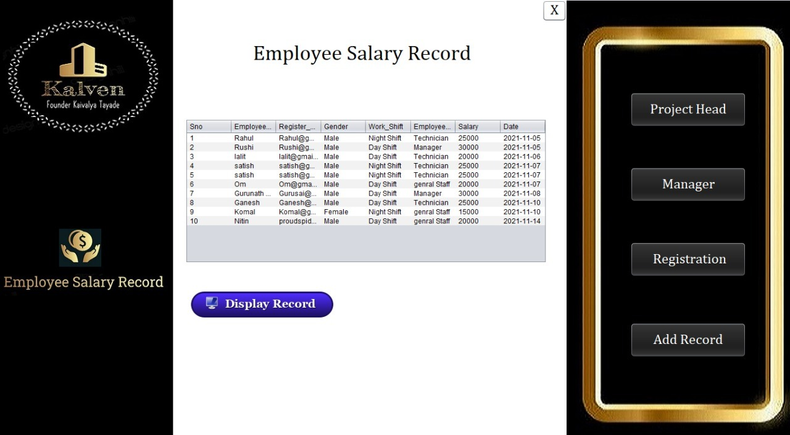

**Head.java**

package employeproject1;

import java.sql.Connection;

import java.sql.DriverManager;

import java.sql.PreparedStatement;

import javax.swing.JOptionPane;

public class Project_Head extends javax.swing.JFrame {

public Project_Head() {

initComponents();

}

@SuppressWarnings("unchecked")

private void initComponents() {

jComboBox1 = new javax.swing.JComboBox();

buttonGroup1 = new javax.swing.ButtonGroup();

buttonGroup2 = new javax.swing.ButtonGroup();

close = new javax.swing.JButton();

jPanel1 = new javax.swing.JPanel();

jPanel2 = new javax.swing.JPanel();

jLabel7 = new javax.swing.JLabel();

jLabel8 = new javax.swing.JLabel();

jLabel9 = new javax.swing.JLabel();

jLabel1 = new javax.swing.JLabel();

jLabel2 = new javax.swing.JLabel();

Pname = new javax.swing.JTextField();

jLabel3 = new javax.swing.JLabel();

projectname = new javax.swing.JTextField();

Mumbai = new javax.swing.JCheckBox();

New_Delhi = new javax.swing.JCheckBox();

Chennai = new javax.swing.JCheckBox();

jLabel4 = new javax.swing.JLabel();

jLabel5 = new javax.swing.JLabel();

jLabel6 = new javax.swing.JLabel();

member = new javax.swing.JComboBox();

save = new javax.swing.JButton();

jButton2 = new javax.swing.JButton();

Plocation = new javax.swing.JComboBox();

jLabel10 = new javax.swing.JLabel();

Hdate = new javax.swing.JTextField();

jButton1 = new javax.swing.JButton();

jComboBox1.setModel(new javax.swing.DefaultComboBoxModel(new String[] { "Item 1", "Item 2", "Item 3", "Item 4" }));

close.setBackground(new java.awt.Color(255, 255, 255));

close.setFont(new java.awt.Font("Calibri", 1, 18)); // NOI18N

close.setText("X");

close.addActionListener(new java.awt.event.ActionListener() {

public void actionPerformed(java.awt.event.ActionEvent evt) {

closeActionPerformed(evt);

}

});

setDefaultCloseOperation(javax.swing.WindowConstants.EXIT_ON_CLOSE);

setUndecorated(true);

jPanel1.setBackground(new java.awt.Color(255, 255, 255));

jPanel2.setBackground(new java.awt.Color(0, 0, 0));

jLabel7.setIcon(new javax.swing.ImageIcon("C:\\Users\\kaiva\\Desktop\\Employee project\\New_Employee\\kaivalya.jpg")); // NOI18N

jLabel8.setIcon(new javax.swing.ImageIcon("C:\\Users\\kaiva\\Desktop\\project files\\Head1.PNG")); // NOI18N

jLabel9.setIcon(new javax.swing.ImageIcon("C:\\Users\\kaiva\\Desktop\\0.PNG")); // NOI18N

jLabel9.setText("jLabel9");

javax.swing.GroupLayout jPanel2Layout = new javax.swing.GroupLayout(jPanel2);

jPanel2.setLayout(jPanel2Layout);

jPanel2Layout.setHorizontalGroup(

jPanel2Layout.createParallelGroup(javax.swing.GroupLayout.Alignment.LEADING)

.addGroup(jPanel2Layout.createSequentialGroup()

.addGroup(jPanel2Layout.createParallelGroup(javax.swing.GroupLayout.Alignment.LEADING)

.addGroup(jPanel2Layout.createSequentialGroup()

.addContainerGap(30, Short.MAX_VALUE)

.addComponent(jLabel8)

.addPreferredGap(javax.swing.LayoutStyle.ComponentPlacement.RELATED)

.addComponent(jLabel9, javax.swing.GroupLayout.PREFERRED_SIZE, 228, javax.swing.GroupLayout.PREFERRED_SIZE))

.addGroup(jPanel2Layout.createSequentialGroup()

.addGap(43, 43, 43)

.addComponent(jLabel7, javax.swing.GroupLayout.PREFERRED_SIZE, 270, javax.swing.GroupLayout.PREFERRED_SIZE)

.addGap(0, 0, Short.MAX_VALUE)))

.addContainerGap())

);

jPanel2Layout.setVerticalGroup(

jPanel2Layout.createParallelGroup(javax.swing.GroupLayout.Alignment.LEADING)

.addGroup(jPanel2Layout.createSequentialGroup()

.addGap(66, 66, 66)

.addComponent(jLabel7, javax.swing.GroupLayout.PREFERRED_SIZE, 230, javax.swing.GroupLayout.PREFERRED_SIZE)

.addGroup(jPanel2Layout.createParallelGroup(javax.swing.GroupLayout.Alignment.LEADING)

.addGroup(jPanel2Layout.createSequentialGroup()

.addGap(110, 110, 110)

.addComponent(jLabel9, javax.swing.GroupLayout.PREFERRED_SIZE, 60, javax.swing.GroupLayout.PREFERRED_SIZE))

.addGroup(jPanel2Layout.createSequentialGroup()

.addGap(96, 96, 96)

.addComponent(jLabel8, javax.swing.GroupLayout.PREFERRED_SIZE, 91, javax.swing.GroupLayout.PREFERRED_SIZE)))

.addContainerGap(javax.swing.GroupLayout.DEFAULT_SIZE, Short.MAX_VALUE))

);

jLabel1.setFont(new java.awt.Font("Cambria Math", 1, 36)); // NOI18N

jLabel1.setText("Project Head");

jLabel2.setFont(new java.awt.Font("Cambria Math", 0, 18)); // NOI18N

jLabel2.setText("Name");

Pname.setFont(new java.awt.Font("Cambria Math", 0, 18)); // NOI18N

Pname.addActionListener(new java.awt.event.ActionListener() {

public void actionPerformed(java.awt.event.ActionEvent evt) {

PnameActionPerformed(evt);

}

});

jLabel3.setFont(new java.awt.Font("Cambria Math", 0, 18)); // NOI18N

jLabel3.setText("Task");

projectname.setFont(new java.awt.Font("Cambria Math", 0, 18)); // NOI18N

projectname.addActionListener(new java.awt.event.ActionListener() {

public void actionPerformed(java.awt.event.ActionEvent evt) {

projectnameActionPerformed(evt);

}

});

buttonGroup1.add(Mumbai);

Mumbai.setFont(new java.awt.Font("Cambria Math", 0, 18)); // NOI18N

Mumbai.setText("Mumbai");

Mumbai.addActionListener(new java.awt.event.ActionListener() {

public void actionPerformed(java.awt.event.ActionEvent evt) {

MumbaiActionPerformed(evt);

}

});

buttonGroup1.add(New_Delhi);

New_Delhi.setFont(new java.awt.Font("Cambria Math", 0, 18)); // NOI18N

New_Delhi.setText("New Delhi");

buttonGroup1.add(Chennai);

Chennai.setFont(new java.awt.Font("Cambria Math", 0, 18)); // NOI18N

Chennai.setText("Chennai");

jLabel4.setFont(new java.awt.Font("Cambria Math", 0, 18)); // NOI18N

jLabel4.setText("Branch");

jLabel5.setFont(new java.awt.Font("Cambria Math", 0, 18)); // NOI18N

jLabel5.setText("Location");

jLabel6.setFont(new java.awt.Font("Cambria Math", 0, 18)); // NOI18N

jLabel6.setText("Team Member");

member.setFont(new java.awt.Font("Cambria Math", 0, 18)); // NOI18N

member.setModel(new javax.swing.DefaultComboBoxModel(new String[] { "20", "30", "40", "50" }));

save.setFont(new java.awt.Font("Cambria Math", 0, 18)); // NOI18N

save.setIcon(new javax.swing.ImageIcon("C:\\Users\\kaiva\\Desktop\\Employee project\\save.png")); // NOI18N

save.setBorder(null);

save.setContentAreaFilled(false);

save.addActionListener(new java.awt.event.ActionListener() {

public void actionPerformed(java.awt.event.ActionEvent evt) {

saveActionPerformed(evt);

}

});

jButton2.setFont(new java.awt.Font("Cambria Math", 0, 18)); // NOI18N

jButton2.setIcon(new javax.swing.ImageIcon("C:\\Users\\kaiva\\Desktop\\Employee project\\Reset1.png")); // NOI18N

jButton2.setBorder(null);

jButton2.setContentAreaFilled(false);

jButton2.addActionListener(new java.awt.event.ActionListener() {

public void actionPerformed(java.awt.event.ActionEvent evt) {

jButton2ActionPerformed(evt);

}

});

Plocation.setFont(new java.awt.Font("Cambria Math", 0, 18)); // NOI18N

Plocation.setModel(new javax.swing.DefaultComboBoxModel(new String[] { "None", "Andheri", "Goregaon", "Bandra", "Kurla", "Dehra Dun", "jaipur", "Koyambedu" }));

jLabel10.setFont(new java.awt.Font("Cambria Math", 0, 18)); // NOI18N

jLabel10.setText("Date");

Hdate.addActionListener(new java.awt.event.ActionListener() {

public void actionPerformed(java.awt.event.ActionEvent evt) {

HdateActionPerformed(evt);

}

});

jButton1.setFont(new java.awt.Font("Cambria Math", 0, 18)); // NOI18N

jButton1.setText("X");

jButton1.addActionListener(new java.awt.event.ActionListener() {

public void actionPerformed(java.awt.event.ActionEvent evt) {

jButton1ActionPerformed(evt);

}

});

javax.swing.GroupLayout jPanel1Layout = new javax.swing.GroupLayout(jPanel1);

jPanel1.setLayout(jPanel1Layout);

jPanel1Layout.setHorizontalGroup(

jPanel1Layout.createParallelGroup(javax.swing.GroupLayout.Alignment.LEADING)

.addGroup(jPanel1Layout.createSequentialGroup()

.addComponent(jPanel2, javax.swing.GroupLayout.PREFERRED_SIZE, javax.swing.GroupLayout.DEFAULT_SIZE, javax.swing.GroupLayout.PREFERRED_SIZE)

.addGroup(jPanel1Layout.createParallelGroup(javax.swing.GroupLayout.Alignment.LEADING)

.addGroup(jPanel1Layout.createSequentialGroup()

.addGroup(jPanel1Layout.createParallelGroup(javax.swing.GroupLayout.Alignment.LEADING)

.addGroup(jPanel1Layout.createSequentialGroup()

.addGap(211, 211, 211)

.addComponent(jLabel1, javax.swing.GroupLayout.PREFERRED_SIZE, 265, javax.swing.GroupLayout.PREFERRED_SIZE))

.addGroup(jPanel1Layout.createSequentialGroup()

.addGap(172, 172, 172)

.addComponent(save)

.addGap(118, 118, 118)

.addComponent(jButton2))

.addGroup(jPanel1Layout.createSequentialGroup()

.addGap(85, 85, 85)

.addGroup(jPanel1Layout.createParallelGroup(javax.swing.GroupLayout.Alignment.LEADING)

.addComponent(jLabel10)

.addComponent(jLabel6)

.addComponent(jLabel5)

.addComponent(jLabel3)

.addComponent(jLabel4)

.addComponent(jLabel2))

.addGap(39, 39, 39)

.addGroup(jPanel1Layout.createParallelGroup(javax.swing.GroupLayout.Alignment.LEADING, false)

.addComponent(projectname)

.addComponent(member, javax.swing.GroupLayout.Alignment.TRAILING, 0, javax.swing.GroupLayout.DEFAULT_SIZE, Short.MAX_VALUE)

.addComponent(Plocation, 0, javax.swing.GroupLayout.DEFAULT_SIZE, Short.MAX_VALUE)

.addComponent(Hdate)

.addGroup(jPanel1Layout.createSequentialGroup()

.addComponent(Mumbai)

.addGap(30, 30, 30)

.addComponent(New_Delhi)

.addPreferredGap(javax.swing.LayoutStyle.ComponentPlacement.RELATED, javax.swing.GroupLayout.DEFAULT_SIZE, Short.MAX_VALUE)

.addComponent(Chennai))

.addComponent(Pname, javax.swing.GroupLayout.PREFERRED_SIZE, 339, javax.swing.GroupLayout.PREFERRED_SIZE))))

.addContainerGap(123, Short.MAX_VALUE))

.addGroup(javax.swing.GroupLayout.Alignment.TRAILING, jPanel1Layout.createSequentialGroup()

.addPreferredGap(javax.swing.LayoutStyle.ComponentPlacement.RELATED, javax.swing.GroupLayout.DEFAULT_SIZE, Short.MAX_VALUE)

.addComponent(jButton1))))

);

jPanel1Layout.setVerticalGroup(

jPanel1Layout.createParallelGroup(javax.swing.GroupLayout.Alignment.LEADING)

.addGroup(jPanel1Layout.createSequentialGroup()

.addComponent(jButton1)

.addGap(22, 22, 22)

.addComponent(jLabel1, javax.swing.GroupLayout.PREFERRED_SIZE, 36, javax.swing.GroupLayout.PREFERRED_SIZE)

.addGap(69, 69, 69)

.addGroup(jPanel1Layout.createParallelGroup(javax.swing.GroupLayout.Alignment.TRAILING)

.addGroup(jPanel1Layout.createSequentialGroup()

.addGroup(jPanel1Layout.createParallelGroup(javax.swing.GroupLayout.Alignment.BASELINE)

.addComponent(jLabel2)

.addComponent(Pname, javax.swing.GroupLayout.PREFERRED_SIZE, 30, javax.swing.GroupLayout.PREFERRED_SIZE))

.addGap(41, 41, 41)

.addGroup(jPanel1Layout.createParallelGroup(javax.swing.GroupLayout.Alignment.BASELINE)

.addComponent(Mumbai)

.addComponent(New_Delhi)

.addComponent(Chennai)

.addComponent(jLabel4))

.addGap(52, 52, 52)

.addComponent(projectname, javax.swing.GroupLayout.PREFERRED_SIZE, javax.swing.GroupLayout.DEFAULT_SIZE, javax.swing.GroupLayout.PREFERRED_SIZE))

.addComponent(jLabel3))

.addGap(46, 46, 46)

.addGroup(jPanel1Layout.createParallelGroup(javax.swing.GroupLayout.Alignment.LEADING)

.addComponent(Plocation, javax.swing.GroupLayout.Alignment.TRAILING, javax.swing.GroupLayout.PREFERRED_SIZE, 32, javax.swing.GroupLayout.PREFERRED_SIZE)

.addComponent(jLabel5, javax.swing.GroupLayout.Alignment.TRAILING))

.addGap(40, 40, 40)

.addGroup(jPanel1Layout.createParallelGroup(javax.swing.GroupLayout.Alignment.LEADING)

.addGroup(javax.swing.GroupLayout.Alignment.TRAILING, jPanel1Layout.createSequentialGroup()

.addGroup(jPanel1Layout.createParallelGroup(javax.swing.GroupLayout.Alignment.TRAILING)

.addComponent(jLabel6)

.addComponent(member, javax.swing.GroupLayout.PREFERRED_SIZE, 30, javax.swing.GroupLayout.PREFERRED_SIZE))

.addGap(46, 46, 46)

.addComponent(Hdate, javax.swing.GroupLayout.PREFERRED_SIZE, 30, javax.swing.GroupLayout.PREFERRED_SIZE))

.addComponent(jLabel10, javax.swing.GroupLayout.Alignment.TRAILING))

.addPreferredGap(javax.swing.LayoutStyle.ComponentPlacement.RELATED, 61, Short.MAX_VALUE)

.addGroup(jPanel1Layout.createParallelGroup(javax.swing.GroupLayout.Alignment.LEADING)

.addComponent(jButton2)

.addComponent(save, javax.swing.GroupLayout.PREFERRED_SIZE, 43, javax.swing.GroupLayout.PREFERRED_SIZE))

.addGap(31, 31, 31))

.addComponent(jPanel2, javax.swing.GroupLayout.DEFAULT_SIZE, javax.swing.GroupLayout.DEFAULT_SIZE, Short.MAX_VALUE)

);

javax.swing.GroupLayout layout = new javax.swing.GroupLayout(getContentPane());

getContentPane().setLayout(layout);

layout.setHorizontalGroup(

layout.createParallelGroup(javax.swing.GroupLayout.Alignment.LEADING)

.addComponent(jPanel1, javax.swing.GroupLayout.PREFERRED_SIZE, javax.swing.GroupLayout.DEFAULT_SIZE, javax.swing.GroupLayout.PREFERRED_SIZE)

);

layout.setVerticalGroup(

layout.createParallelGroup(javax.swing.GroupLayout.Alignment.LEADING)

.addComponent(jPanel1, javax.swing.GroupLayout.DEFAULT_SIZE, javax.swing.GroupLayout.DEFAULT_SIZE, Short.MAX_VALUE)

);

pack();

}// </editor-fold>

private void PnameActionPerformed(java.awt.event.ActionEvent evt) { }

private void projectnameActionPerformed(java.awt.event.ActionEvent evt) { }

private void MumbaiActionPerformed(java.awt.event.ActionEvent evt) { }

private void saveActionPerformed(java.awt.event.ActionEvent evt) {

// TODO add your handling code here:

try {

Class.forName("com.mysql.cj.jdbc.Driver");

Connection con = DriverManager.getConnection("jdbc:mysql://localhost/employeelogin1","root","");

String query = "insert into head(Name,Branch,Task,Location,Team_member,Date)values(?,?,?,?,?,?);";

PreparedStatement pst = con.prepareStatement(query);

pst.setString(1, Pname.getText());

String Pgroup=" ";

if(Mumbai.isSelected()){

Pgroup+=Mumbai.getText()+" ";

}

if(New_Delhi.isSelected()){

Pgroup+=New_Delhi.getText()+" ";

}

if(Chennai.isSelected()){

Pgroup+=Chennai.getText()+" ";

}

pst.setString(2, Pgroup);

pst.setString(3, projectname.getText());

String Phost;

Phost = Plocation.getSelectedItem().toString();

pst.setString(4, Phost);

String Pteam;

Pteam = member.getSelectedItem().toString();

pst.setString(5, Pteam);

pst.setDate(6, new java.sql.Date(System.currentTimeMillis()));

pst.executeUpdate();

JOptionPane.showMessageDialog(null, "Inserted Sucessfully");

}

catch(Exception e){

JOptionPane.showMessageDialog(null, e);

}}

private void jButton2ActionPerformed(java.awt.event.ActionEvent evt) {

// TODO add your handling code here:

Pname.setText("");

buttonGroup1.clearSelection();

projectname.setText("");

Plocation.setSelectedIndex(0);

member.setSelectedIndex(0);

}

private void closeActionPerformed(java.awt.event.ActionEvent evt) {

// TODO add your handling code here:

dispose();

}

private void jButton1ActionPerformed(java.awt.event.ActionEvent evt) {

dispose();

}

public static void main(String args[]) {

try {

for (javax.swing.UIManager.LookAndFeelInfo info : javax.swing.UIManager.getInstalledLookAndFeels()) {

if ("Nimbus".equals(info.getName())) {

javax.swing.UIManager.setLookAndFeel(info.getClassName());

break;

}}

} catch (ClassNotFoundException ex) {

java.util.logging.Logger.getLogger(Project_Head.class.getName()).log(java.util.logging.Level.SEVERE, null, ex);

} catch (InstantiationException ex) {

java.util.logging.Logger.getLogger(Project_Head.class.getName()).log(java.util.logging.Level.SEVERE, null, ex);

} catch (IllegalAccessException ex) {

java.util.logging.Logger.getLogger(Project_Head.class.getName()).log(java.util.logging.Level.SEVERE, null, ex);

} catch (javax.swing.UnsupportedLookAndFeelException ex) {

java.util.logging.Logger.getLogger(Project_Head.class.getName()).log(java.util.logging.Level.SEVERE, null, ex);

}

//</editor-fold>

/* Create and display the form */

java.awt.EventQueue.invokeLater(new Runnable() {

public void run() {

new Project_Head().setVisible(true);

}

});

}

private javax.swing.JCheckBox Chennai;

private javax.swing.JTextField Hdate;

private javax.swing.JCheckBox Mumbai;

private javax.swing.JCheckBox New_Delhi;

private javax.swing.JComboBox Plocation;

private javax.swing.JTextField Pname;

private javax.swing.ButtonGroup buttonGroup1;

private javax.swing.ButtonGroup buttonGroup2;

private javax.swing.JButton close;

private javax.swing.JButton jButton1;

private javax.swing.JButton jButton2;

private javax.swing.JComboBox jComboBox1;

private javax.swing.JLabel jLabel1;

private javax.swing.JLabel jLabel10;

private javax.swing.JLabel jLabel2;

private javax.swing.JLabel jLabel3;

private javax.swing.JLabel jLabel4;

private javax.swing.JLabel jLabel5;

private javax.swing.JLabel jLabel6;

private javax.swing.JLabel jLabel7;

private javax.swing.JLabel jLabel8;

private javax.swing.JLabel jLabel9;

private javax.swing.JPanel jPanel1;

private javax.swing.JPanel jPanel2;

private javax.swing.JComboBox member;

private javax.swing.JTextField projectname;

private javax.swing.JButton save;

}

**Output**

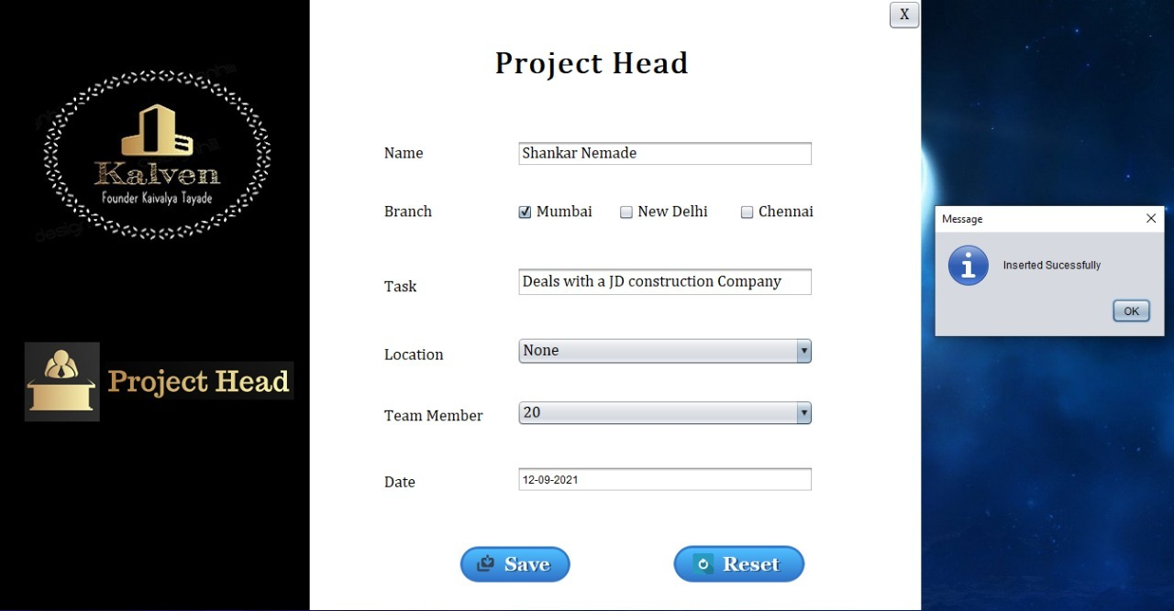

**Database**

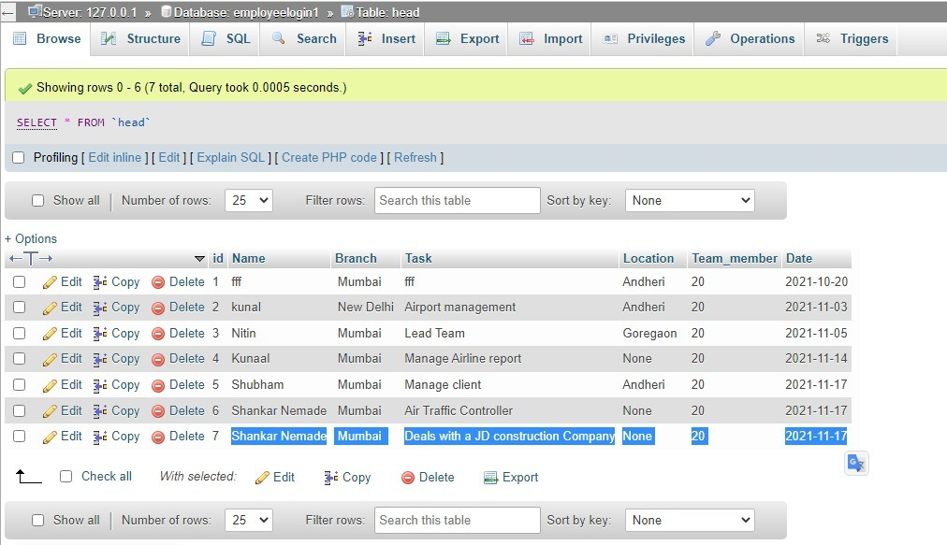

**Manager.java**

package employeproject1;

import java.sql.Connection;

import java.sql.DriverManager;

import java.sql.PreparedStatement;

import javax.swing.JOptionPane;

public class Manager extends javax.swing.JFrame {

public Manager() {

initComponents();

}

@SuppressWarnings("unchecked")

// <editor-fold defaultstate="collapsed" desc="Generated Code">

private void initComponents() {

buttonGroup1 = new javax.swing.ButtonGroup();

buttonGroup2 = new javax.swing.ButtonGroup();

buttonGroup3 = new javax.swing.ButtonGroup();

jPanel1 = new javax.swing.JPanel();

jPanel2 = new javax.swing.JPanel();

jLabel7 = new javax.swing.JLabel();

jLabel8 = new javax.swing.JLabel();

jLabel9 = new javax.swing.JLabel();

jLabel1 = new javax.swing.JLabel();

jLabel2 = new javax.swing.JLabel();

Mname = new javax.swing.JTextField();

jLabel4 = new javax.swing.JLabel();

Mumbai = new javax.swing.JCheckBox();

New_Delhi = new javax.swing.JCheckBox();

Chennai = new javax.swing.JCheckBox();

jLabel3 = new javax.swing.JLabel();

MTask = new javax.swing.JTextField();

jLabel5 = new javax.swing.JLabel();

Mlocation = new javax.swing.JComboBox();

jLabel6 = new javax.swing.JLabel();

MMember = new javax.swing.JComboBox();

MsaveB = new javax.swing.JButton();

MresetB = new javax.swing.JButton();

Close = new javax.swing.JButton();

setDefaultCloseOperation(javax.swing.WindowConstants.EXIT_ON_CLOSE);

setUndecorated(true);

jPanel1.setBackground(new java.awt.Color(255, 255, 255));

jPanel2.setBackground(new java.awt.Color(0, 0, 0));

jLabel7.setIcon(new javax.swing.ImageIcon("C:\\Users\\kaiva\\Desktop\\Employee project\\New_Employee\\kaivalya.jpg")); // NOI18N

jLabel7.setText("jLabel7");

jLabel8.setIcon(new javax.swing.ImageIcon("C:\\Users\\kaiva\\Desktop\\SManager.PNG")); // NOI18N

jLabel9.setIcon(new javax.swing.ImageIcon("C:\\Users\\kaiva\\Desktop\\Employee project\\New_Employee\\Xemployee.PNG")); // NOI18N

javax.swing.GroupLayout jPanel2Layout = new javax.swing.GroupLayout(jPanel2);

jPanel2.setLayout(jPanel2Layout);

jPanel2Layout.setHorizontalGroup(

jPanel2Layout.createParallelGroup(javax.swing.GroupLayout.Alignment.LEADING)

.addGroup(javax.swing.GroupLayout.Alignment.TRAILING, jPanel2Layout.createSequentialGroup()

.addContainerGap(22, Short.MAX_VALUE)

.addGroup(jPanel2Layout.createParallelGroup(javax.swing.GroupLayout.Alignment.LEADING)

.addGroup(javax.swing.GroupLayout.Alignment.TRAILING, jPanel2Layout.createSequentialGroup()

.addComponent(jLabel9)

.addPreferredGap(javax.swing.LayoutStyle.ComponentPlacement.UNRELATED)

.addComponent(jLabel8)

.addGap(42, 42, 42))

.addGroup(jPanel2Layout.createSequentialGroup()

.addComponent(jLabel7, javax.swing.GroupLayout.PREFERRED_SIZE, 290, javax.swing.GroupLayout.PREFERRED_SIZE)

.addGap(20, 20, 20))))

);

jPanel2Layout.setVerticalGroup(

jPanel2Layout.createParallelGroup(javax.swing.GroupLayout.Alignment.LEADING)

.addGroup(jPanel2Layout.createSequentialGroup()

.addGap(60, 60, 60)

.addComponent(jLabel7, javax.swing.GroupLayout.PREFERRED_SIZE, 229, javax.swing.GroupLayout.PREFERRED_SIZE)

.addGap(117, 117, 117)

.addGroup(jPanel2Layout.createParallelGroup(javax.swing.GroupLayout.Alignment.TRAILING)

.addComponent(jLabel9)

.addComponent(jLabel8, javax.swing.GroupLayout.PREFERRED_SIZE, 55, javax.swing.GroupLayout.PREFERRED_SIZE))

.addContainerGap(javax.swing.GroupLayout.DEFAULT_SIZE, Short.MAX_VALUE))

);

jLabel1.setFont(new java.awt.Font("Cambria Math", 1, 36)); // NOI18N

jLabel1.setText("Manager");

jLabel2.setFont(new java.awt.Font("Cambria Math", 0, 24)); // NOI18N

jLabel2.setText("Name");

Mname.addActionListener(new java.awt.event.ActionListener() {

public void actionPerformed(java.awt.event.ActionEvent evt) {

MnameActionPerformed(evt);

}

});

jLabel4.setFont(new java.awt.Font("Cambria Math", 0, 18)); // NOI18N

jLabel4.setText("Branch");

buttonGroup1.add(Mumbai);

Mumbai.setText("Mumbai");

Mumbai.addActionListener(new java.awt.event.ActionListener() {

public void actionPerformed(java.awt.event.ActionEvent evt) {

MumbaiActionPerformed(evt);

}

});

buttonGroup1.add(New_Delhi);

New_Delhi.setText("New Delhi");

New_Delhi.addActionListener(new java.awt.event.ActionListener() {

public void actionPerformed(java.awt.event.ActionEvent evt) {

New_DelhiActionPerformed(evt);

}

});

buttonGroup1.add(Chennai);

Chennai.setText("Chennai");

jLabel3.setFont(new java.awt.Font("Cambria Math", 0, 18)); // NOI18N

jLabel3.setText("Task");

MTask.addActionListener(new java.awt.event.ActionListener() {

public void actionPerformed(java.awt.event.ActionEvent evt) {

MTaskActionPerformed(evt);

}

});

jLabel5.setFont(new java.awt.Font("Cambria Math", 0, 18)); // NOI18N

jLabel5.setText("Location");

Mlocation.setModel(new javax.swing.DefaultComboBoxModel(new String[] { "None", "Andheri", "Goregaon", "Bandra", "Kurla", "Dehra Dun", "jaipur", "Koyambedu" }));

Mlocation.addActionListener(new java.awt.event.ActionListener() {

public void actionPerformed(java.awt.event.ActionEvent evt) {

MlocationActionPerformed(evt);

}

});

jLabel6.setFont(new java.awt.Font("Cambria Math", 0, 18)); // NOI18N

jLabel6.setText("Team Member");

MMember.setModel(new javax.swing.DefaultComboBoxModel(new String[] { "10", "15", "20", "25", "30" }));

MMember.addActionListener(new java.awt.event.ActionListener() {

public void actionPerformed(java.awt.event.ActionEvent evt) {

MMemberActionPerformed(evt);

}

});

MsaveB.setFont(new java.awt.Font("Cambria Math", 0, 24)); // NOI18N

MsaveB.setIcon(new javax.swing.ImageIcon("C:\\Users\\kaiva\\Desktop\\Employee project\\save1.png")); // NOI18N

MsaveB.setBorder(null);

MsaveB.setContentAreaFilled(false);

MsaveB.addActionListener(new java.awt.event.ActionListener() {

public void actionPerformed(java.awt.event.ActionEvent evt) {

MsaveBActionPerformed(evt);

}

});

MresetB.setFont(new java.awt.Font("Cambria Math", 0, 24)); // NOI18N

MresetB.setIcon(new javax.swing.ImageIcon("C:\\Users\\kaiva\\Desktop\\Employee project\\Reset1.png")); // NOI18N

MresetB.setBorder(null);

MresetB.setContentAreaFilled(false);

MresetB.addActionListener(new java.awt.event.ActionListener() {

public void actionPerformed(java.awt.event.ActionEvent evt) {

MresetBActionPerformed(evt);

}

});

Close.setBackground(new java.awt.Color(255, 255, 255));

Close.setFont(new java.awt.Font("Cambria Math", 0, 18)); // NOI18N

Close.setText("X");

Close.setBorder(null);

Close.addActionListener(new java.awt.event.ActionListener() {

public void actionPerformed(java.awt.event.ActionEvent evt) {

CloseActionPerformed(evt);

}

});

javax.swing.GroupLayout jPanel1Layout = new javax.swing.GroupLayout(jPanel1);

jPanel1.setLayout(jPanel1Layout);

jPanel1Layout.setHorizontalGroup(

jPanel1Layout.createParallelGroup(javax.swing.GroupLayout.Alignment.LEADING)

.addGroup(jPanel1Layout.createSequentialGroup()

.addComponent(jPanel2, javax.swing.GroupLayout.PREFERRED_SIZE, javax.swing.GroupLayout.DEFAULT_SIZE, javax.swing.GroupLayout.PREFERRED_SIZE)

.addGroup(jPanel1Layout.createParallelGroup(javax.swing.GroupLayout.Alignment.LEADING)

.addGroup(jPanel1Layout.createSequentialGroup()

.addGroup(jPanel1Layout.createParallelGroup(javax.swing.GroupLayout.Alignment.LEADING)

.addGroup(jPanel1Layout.createSequentialGroup()

.addGap(44, 44, 44)

.addGroup(jPanel1Layout.createParallelGroup(javax.swing.GroupLayout.Alignment.LEADING)

.addGroup(jPanel1Layout.createSequentialGroup()

.addGroup(jPanel1Layout.createParallelGroup(javax.swing.GroupLayout.Alignment.LEADING)

.addComponent(jLabel2)

.addComponent(jLabel4)

.addComponent(jLabel5))

.addGap(117, 117, 117)

.addGroup(jPanel1Layout.createParallelGroup(javax.swing.GroupLayout.Alignment.LEADING, false)

.addComponent(MMember, 0, javax.swing.GroupLayout.DEFAULT_SIZE, Short.MAX_VALUE)

.addComponent(Mlocation, 0, javax.swing.GroupLayout.DEFAULT_SIZE, Short.MAX_VALUE)

.addGroup(jPanel1Layout.createSequentialGroup()

.addComponent(Mumbai)

.addGap(44, 44, 44)

.addComponent(New_Delhi)

.addPreferredGap(javax.swing.LayoutStyle.ComponentPlacement.RELATED, 59, Short.MAX_VALUE)

.addComponent(Chennai)

.addGap(16, 16, 16))

.addComponent(MTask)

.addComponent(Mname)))

.addComponent(jLabel3)

.addComponent(jLabel6)))

.addGroup(jPanel1Layout.createSequentialGroup()

.addGap(126, 126, 126)

.addComponent(MsaveB)

.addGap(81, 81, 81)

.addComponent(MresetB)))

.addContainerGap(77, Short.MAX_VALUE))

.addGroup(javax.swing.GroupLayout.Alignment.TRAILING, jPanel1Layout.createSequentialGroup()

.addPreferredGap(javax.swing.LayoutStyle.ComponentPlacement.RELATED, javax.swing.GroupLayout.DEFAULT_SIZE, Short.MAX_VALUE)

.addComponent(jLabel1, javax.swing.GroupLayout.PREFERRED_SIZE, 175, javax.swing.GroupLayout.PREFERRED_SIZE)

.addGap(194, 194, 194)

.addComponent(Close, javax.swing.GroupLayout.PREFERRED_SIZE, 37, javax.swing.GroupLayout.PREFERRED_SIZE))))

);

jPanel1Layout.setVerticalGroup(

jPanel1Layout.createParallelGroup(javax.swing.GroupLayout.Alignment.LEADING)

.addComponent(jPanel2, javax.swing.GroupLayout.DEFAULT_SIZE, javax.swing.GroupLayout.DEFAULT_SIZE, Short.MAX_VALUE)

.addGroup(jPanel1Layout.createSequentialGroup()

.addGroup(jPanel1Layout.createParallelGroup(javax.swing.GroupLayout.Alignment.LEADING)

.addGroup(jPanel1Layout.createSequentialGroup()

.addGap(30, 30, 30)

.addComponent(jLabel1))

.addComponent(Close, javax.swing.GroupLayout.PREFERRED_SIZE, 34, javax.swing.GroupLayout.PREFERRED_SIZE))

.addGap(76, 76, 76)

.addGroup(jPanel1Layout.createParallelGroup(javax.swing.GroupLayout.Alignment.LEADING)

.addGroup(jPanel1Layout.createSequentialGroup()

.addComponent(jLabel2, javax.swing.GroupLayout.DEFAULT_SIZE, javax.swing.GroupLayout.DEFAULT_SIZE, Short.MAX_VALUE)

.addGap(39, 39, 39))

.addGroup(jPanel1Layout.createSequentialGroup()

.addComponent(Mname, javax.swing.GroupLayout.PREFERRED_SIZE, 29, javax.swing.GroupLayout.PREFERRED_SIZE)

.addPreferredGap(javax.swing.LayoutStyle.ComponentPlacement.RELATED, javax.swing.GroupLayout.DEFAULT_SIZE, Short.MAX_VALUE)))

.addGroup(jPanel1Layout.createParallelGroup(javax.swing.GroupLayout.Alignment.LEADING)

.addGroup(javax.swing.GroupLayout.Alignment.TRAILING, jPanel1Layout.createSequentialGroup()

.addGroup(jPanel1Layout.createParallelGroup(javax.swing.GroupLayout.Alignment.BASELINE)

.addComponent(jLabel4)

.addComponent(Mumbai)

.addComponent(New_Delhi)

.addComponent(Chennai))

.addGap(125, 125, 125))

.addGroup(javax.swing.GroupLayout.Alignment.TRAILING, jPanel1Layout.createSequentialGroup()

.addGroup(jPanel1Layout.createParallelGroup(javax.swing.GroupLayout.Alignment.BASELINE)

.addComponent(Mlocation, javax.swing.GroupLayout.PREFERRED_SIZE, 32, javax.swing.GroupLayout.PREFERRED_SIZE)

.addComponent(jLabel5))

.addGap(56, 56, 56)))

.addGroup(jPanel1Layout.createParallelGroup(javax.swing.GroupLayout.Alignment.BASELINE)

.addComponent(jLabel3)

.addComponent(MTask, javax.swing.GroupLayout.PREFERRED_SIZE, 30, javax.swing.GroupLayout.PREFERRED_SIZE))

.addGap(48, 48, 48)

.addGroup(jPanel1Layout.createParallelGroup(javax.swing.GroupLayout.Alignment.BASELINE)

.addComponent(jLabel6)

.addComponent(MMember, javax.swing.GroupLayout.PREFERRED_SIZE, 30, javax.swing.GroupLayout.PREFERRED_SIZE))

.addGap(66, 66, 66)

.addGroup(jPanel1Layout.createParallelGroup(javax.swing.GroupLayout.Alignment.BASELINE)

.addComponent(MsaveB, javax.swing.GroupLayout.PREFERRED_SIZE, 49, javax.swing.GroupLayout.PREFERRED_SIZE)

.addComponent(MresetB, javax.swing.GroupLayout.PREFERRED_SIZE, 49, javax.swing.GroupLayout.PREFERRED_SIZE))

.addGap(37, 37, 37))

);

javax.swing.GroupLayout layout = new javax.swing.GroupLayout(getContentPane());

getContentPane().setLayout(layout);

layout.setHorizontalGroup(

layout.createParallelGroup(javax.swing.GroupLayout.Alignment.LEADING)

.addComponent(jPanel1, javax.swing.GroupLayout.DEFAULT_SIZE, javax.swing.GroupLayout.DEFAULT_SIZE, Short.MAX_VALUE)

);

layout.setVerticalGroup(

layout.createParallelGroup(javax.swing.GroupLayout.Alignment.LEADING)

.addGroup(layout.createSequentialGroup()

.addComponent(jPanel1, javax.swing.GroupLayout.PREFERRED_SIZE, javax.swing.GroupLayout.DEFAULT_SIZE, javax.swing.GroupLayout.PREFERRED_SIZE)

.addGap(0, 0, Short.MAX_VALUE))

);

pack();

}// </editor-fold>

private void MnameActionPerformed(java.awt.event.ActionEvent evt) {

// TODO add your handling code here:

}

private void MumbaiActionPerformed(java.awt.event.ActionEvent evt) {

// TODO add your handling code here:

}

private void MTaskActionPerformed(java.awt.event.ActionEvent evt) {

// TODO add your handling code here:

}

private void MsaveBActionPerformed(java.awt.event.ActionEvent evt) {

// TODO add your handling code here:

try {

Class.forName("com.mysql.cj.jdbc.Driver");

Connection con = DriverManager.getConnection("jdbc:mysql://localhost/employeelogin1","root","");

String query = "insert into manager(Manager_Name,Branch,Location,Task,Team_member)values(?,?,?,?,?);";

PreparedStatement pst = con.prepareStatement(query);

pst.setString(1, Mname.getText());

String out=" ";

if(Mumbai.isSelected()){

out+=Mumbai.getText()+" ";

}

if(New_Delhi.isSelected()){

out+=New_Delhi.getText()+" ";

}

if(Chennai.isSelected()){

out+=Chennai.getText()+" ";

}

pst.setString(2, out);

String host;

host = Mlocation.getSelectedItem().toString();

pst.setString(3, host);

pst.setString(4, MTask.getText());

String Team;

Team = MMember.getSelectedItem().toString();

pst.setString(5, Team);

pst.executeUpdate();

JOptionPane.showMessageDialog(null, "Inserted Sucessfully");

}

catch(Exception e){

JOptionPane.showMessageDialog(null, e);

}}

private void MresetBActionPerformed(java.awt.event.ActionEvent evt) {

// TODO add your handling code here:

Mname.setText("");

buttonGroup1.clearSelection();

Mlocation.setSelectedIndex(0);

MTask.setText("");

MMember.setSelectedIndex(0);

}

private void New_DelhiActionPerformed(java.awt.event.ActionEvent evt) {

// TODO add your handling code here:

}

private void MlocationActionPerformed(java.awt.event.ActionEvent evt) {

// TODO add your handling code here:

}

private void MMemberActionPerformed(java.awt.event.ActionEvent evt) {

// TODO add your handling code here:

}

private void CloseActionPerformed(java.awt.event.ActionEvent evt) {

dispose();

}

public static void main(String args[]) {

try {

for (javax.swing.UIManager.LookAndFeelInfo info : javax.swing.UIManager.getInstalledLookAndFeels()) {

if ("Nimbus".equals(info.getName())) {

javax.swing.UIManager.setLookAndFeel(info.getClassName());

break;

}

}

} catch (ClassNotFoundException ex) {

java.util.logging.Logger.getLogger(Manager.class.getName()).log(java.util.logging.Level.SEVERE, null, ex);

} catch (InstantiationException ex) {

java.util.logging.Logger.getLogger(Manager.class.getName()).log(java.util.logging.Level.SEVERE, null, ex);

} catch (IllegalAccessException ex) {

java.util.logging.Logger.getLogger(Manager.class.getName()).log(java.util.logging.Level.SEVERE, null, ex);

} catch (javax.swing.UnsupportedLookAndFeelException ex) {

java.util.logging.Logger.getLogger(Manager.class.getName()).log(java.util.logging.Level.SEVERE, null, ex);

}

//</editor-fold>

/* Create and display the form */

java.awt.EventQueue.invokeLater(new Runnable() {

public void run() {

new Manager().setVisible(true);

}

});

}

private javax.swing.JCheckBox Chennai;

private javax.swing.JButton Close;

private javax.swing.JComboBox MMember;

private javax.swing.JTextField MTask;

private javax.swing.JComboBox Mlocation;

private javax.swing.JTextField Mname;

private javax.swing.JButton MresetB;

private javax.swing.JButton MsaveB;

private javax.swing.JCheckBox Mumbai;

private javax.swing.JCheckBox New_Delhi;

private javax.swing.ButtonGroup buttonGroup1;

private javax.swing.ButtonGroup buttonGroup2;

private javax.swing.ButtonGroup buttonGroup3;

private javax.swing.JLabel jLabel1;

private javax.swing.JLabel jLabel2;

private javax.swing.JLabel jLabel3;

private javax.swing.JLabel jLabel4;

private javax.swing.JLabel jLabel5;

private javax.swing.JLabel jLabel6;

private javax.swing.JLabel jLabel7;

private javax.swing.JLabel jLabel8;

private javax.swing.JLabel jLabel9;

private javax.swing.JPanel jPanel1;

private javax.swing.JPanel jPanel2;

// End of variables declaration

}

**Output**

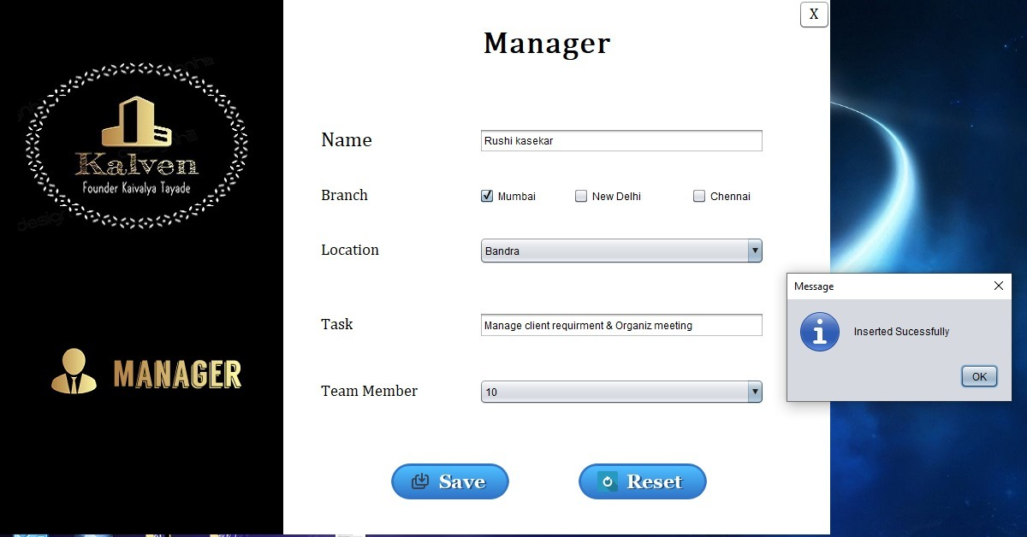

**Database**

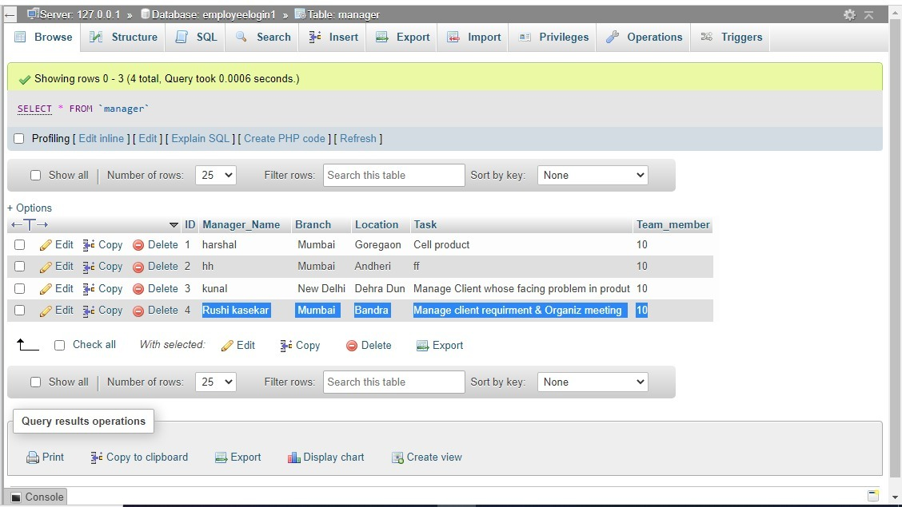

**Validation**

**____________________________________________________________________________________________________________________________**

**KalvenID.java**

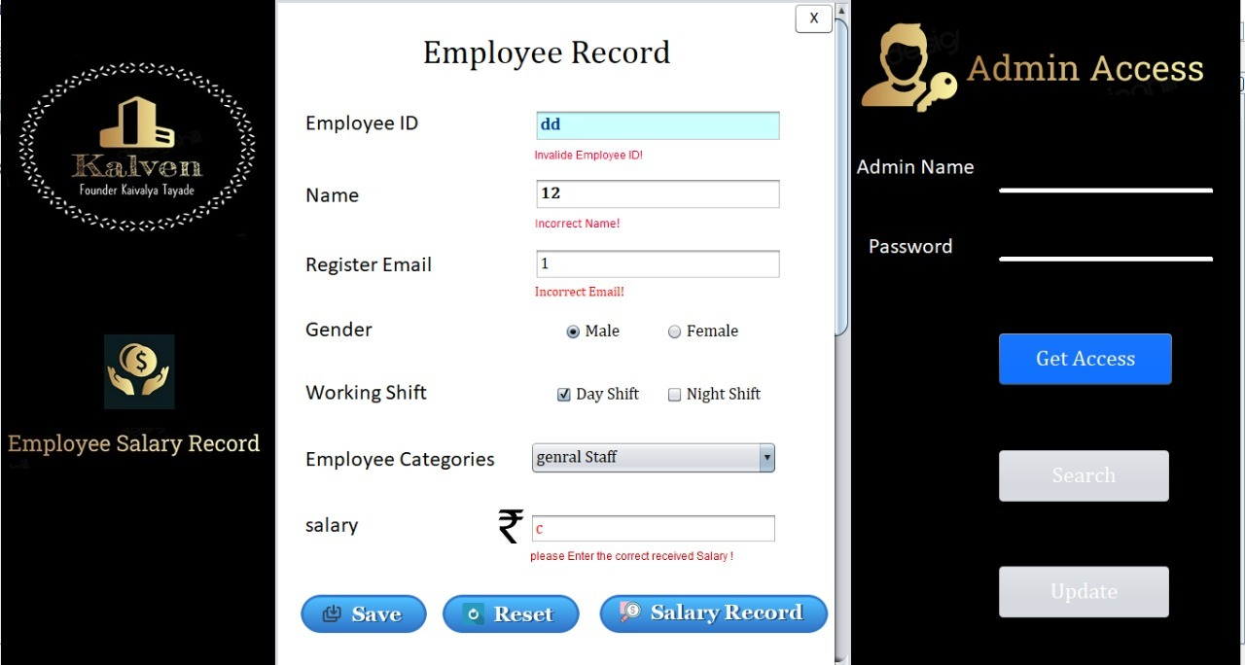

**NewRegistration.java**

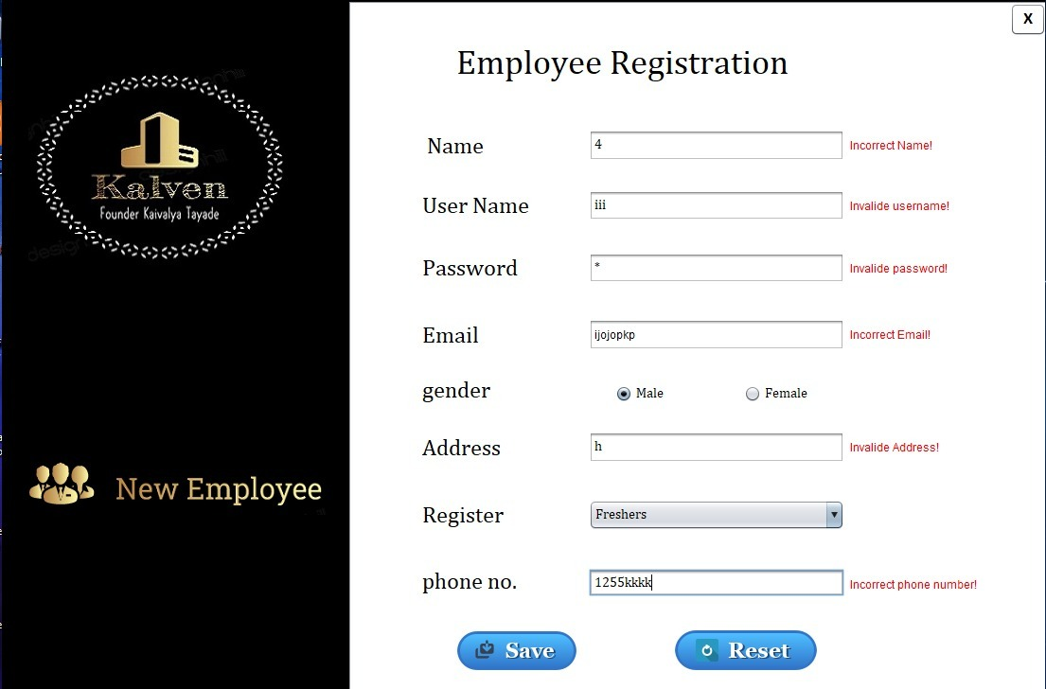

**Conclusion:**

It’s easy to generates reports of all employees (using other application like Excel), Payments and salary slips as per the record. You can easily export PDF for employee (using other application), Payroll, Pay slips, Allowance and deduction records. Save PDF to any location,own by using Salary record. **It’s easy way to stored employee salary Record instead of a paper work**

**Future Enhancement**

* Development of application is one time effort but its maintenance is continuously dynamically. It forces the developers to continuously develop new ideas which will make this application more user friendly and easy to use.
* So according to my perspective, the following modules can be subjected to further enhancements :-
* The module where Employee will be able to add their photo with brif Details.
* Add more SQL operations according to Company needs to fetch the details
* Updated login and logout functionality can be added.
* Add functionality for generate Employee salary record in detail